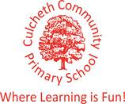

Our Sporting Diary 2017 – 2018

September

Charity Skydive

On the 1st September, our Headteacher, Mrs Dodd, undertook the challenge of completing a skydive for charity. The small plane took off with Mrs Dodd inside, and after it reached 3 miles high, the small shutter opened and Mrs Dodd jumped out of the plane. She was so incredibly brave! Travelling at 125 mph for the first 30 seconds of the fall must have been very scary. Mrs Dodd raised a huge amount of money for The Children’s Cancer Ward Piam Brown. Well done Mrs Dodd!

CPD Real Gymnastics

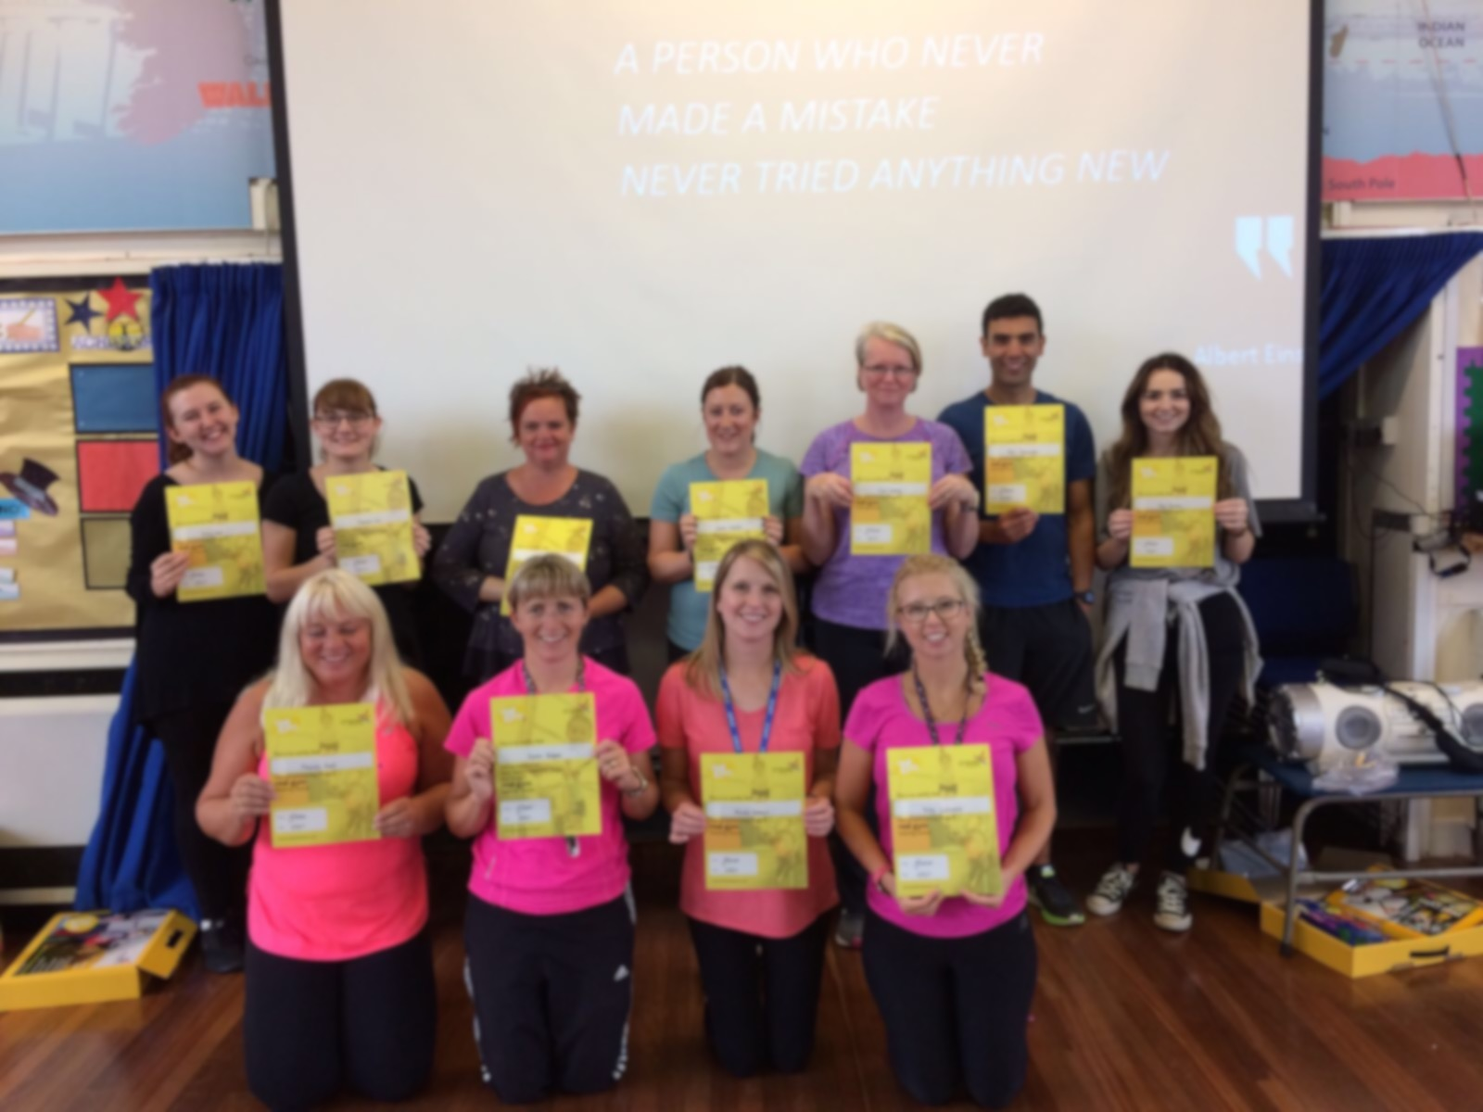
All of the teaching staff attended and successfully completed training delivered by Jan Parker on REAL Gymnastics. The training was held as an inset day at our school. It was a fantastic course and has provided all teaching staff with the skills, knowledge and resources needed to deliver effective, challenging and differentiated gymnastics lessons. From the course, we learnt how to teach the skills and build the difficulty and challenge up in order to challenge more able children. We also looked at how we can teach gymnastics not only indoors, but also outdoors. Both outdoor areas, KS1 and KS2 have access to fantastic equipment which children can use during gymnastics lessons, to explore making shapes as well as exploring balance and jumps, but children can also use this equipment and their knowledge from gymnastics lessons during break time to practise their skills. This aids in making gymnastics fun and accessible not only in lessons but at break times as well. All staff really enjoyed the training and feel more prepared and ready to give REAL gymnastics a try in their PE lessons. One member of staff commented “The course has been really beneficial. It has not only developed my knowledge of how gymnastics skills are developed throughout the school, but by also looking at safety, especially on apparatus, it has developed my confidence in bringing out the climbing frames ect out more in lessons.”

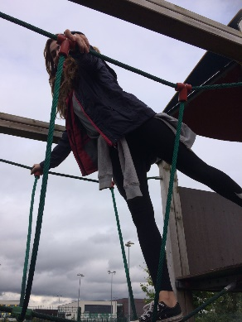
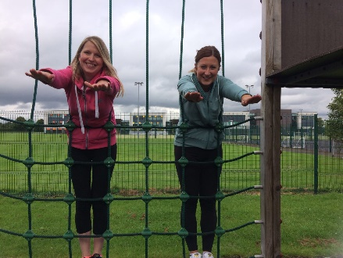

100 mile challenge

After last year’s success, each child in KS2 has been set the challenge to complete 100 miles over the academic year again. The children thoroughly enjoyed this last year and we have chosen to set the children this challenge again. Everyday, the children will take part in completing a mile and they do this on the track around our school field. All children are extremely enthusiastic to complete this challenge and to monitor their steps over the year.

Total Gymnastics Assembly

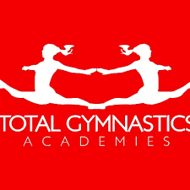
On Friday 7th July, Total Gymnastics visited the school and delivered an assembly. The assembly was focused around how gymnastics can develop a range of fundamental movements. They also focused on the importance of trying new things, encouraging the children to partake in new sports (you never know how good you might be unless you have tried). The children thoroughly enjoyed the assembly and were even offered a free taster session.

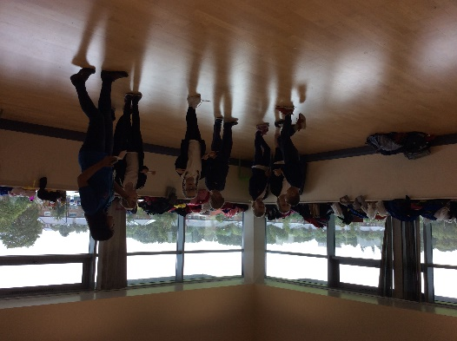
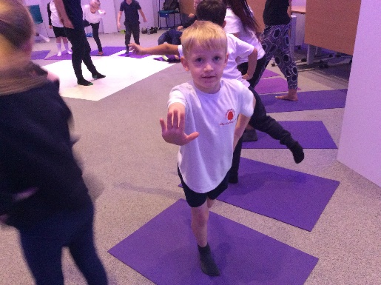
KS1 Road to the Gold Coast Event

We took 30 children from KS1 to the festival ‘Road to the Gold Coast’. The children took part in a range of activities including: Yoga, Dance, Drama and multi-skills. They also had the opportunity to take part in workshops which taught them about keeping a balanced diet and its importance. The children had a fantastic time.

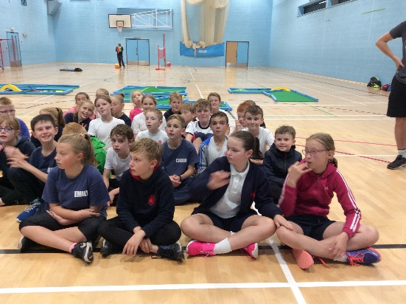
KS2 Triathlon Event

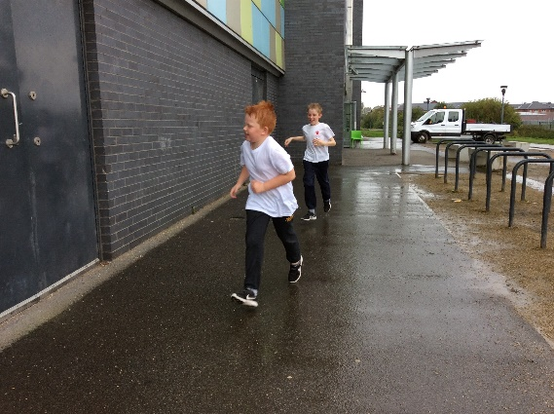
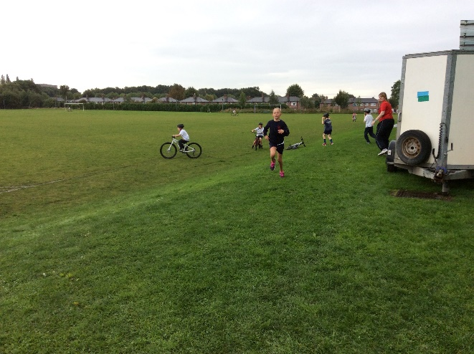
On Friday 22nd September, 27 children from years 4, 5 and 6 attended a triathlon event at Orford Jubilee Hub. The children were required to swim for 25m, complete a short bike ride as well as a run all in the confines of Orford Jubilee Hub. All of the children had a brilliant time exploring the new sports involved in the triathlon.

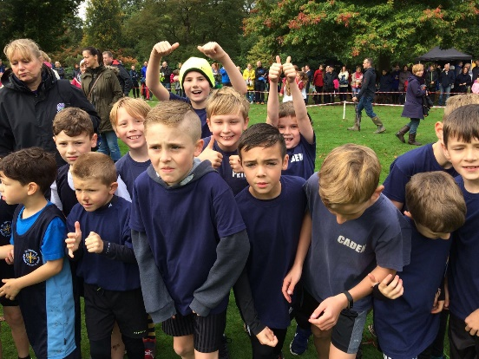
Walton Gardens Cross Country

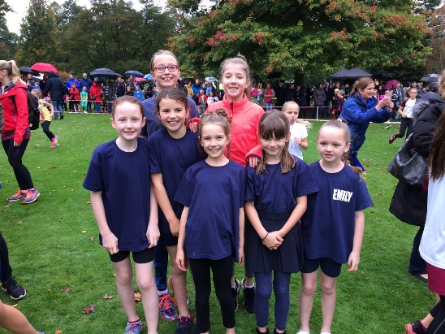
On Saturday 30th September, the running team took part in the first of three cross country races. The children did exceptionally well in the rain and wind. Everyone is looking forward to the next two races to see if we can improve on our first performance of this academic year.

October

Tennis Workshop

KS1 children had the opportunity to take part in a tennis work shop on Monday 2nd October. All children really enjoyed the taster session. They learned lots of new skills as well as being given the opportunity to apply their learned skills from our REAL PE scheme to a game situation.

Ability Day

6 children attended the ability day at Orford Jubilee Hub on Wednesday 11th October. The aim of the day was to provide students, who would not normally get the opportunity to represent their school, the chance to partake in multi-sport activities. The children had the chance to take part in football, archery, boccia and table cricket. Each child left with a medal for partaking in the day.

Year 3/4 Basketball Development Day

Seven children from years 3 and 4 took part in a basketball development session on Tuesday 17th October at Sir Thomas Botler Ball Hall. This event was run by Warrington Sports Partnership and involved the children playing a total of 4 matches. The event was aimed at developing children’s basketball skills in game situations and for all of the children who took part, it was their first ever time playing a basketball match. Overall, the children won two matches and lost one match. They all played brilliantly and thoroughly enjoyed the event.

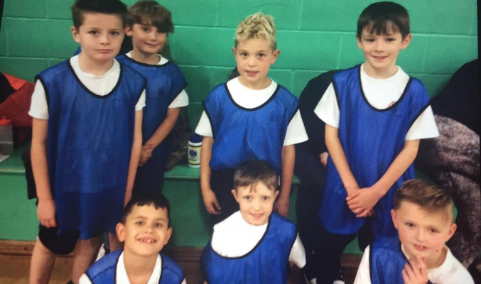

Year 5/6 Football Match

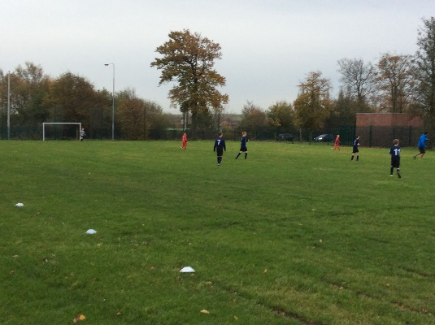
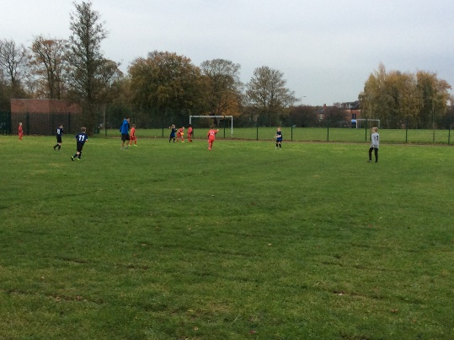
On Tuesday 31st October our Year 5/6 Football team took on Birchwood Primary School in a friendly match, at home, on our school field. Mr Chesworth refereed the match and all of the boys tried their best. Fun was had by all and the boys are looking forward to the next match.

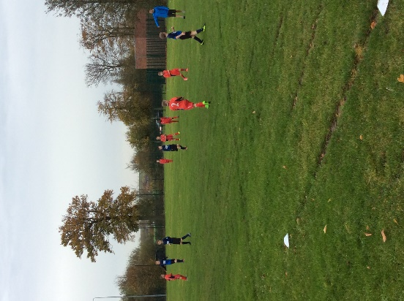

Year 3/4 and Year 5/6 Football Match

On Tuesday 7th November both of our football teams played a friendly match against Chapelford Village Primary School. All of the boys who played tried really hard and despite the cold, really enjoyed the game. It was fantastic to see the teamwork and great sportsmanship on display from all involved. Mr Chesworth refereed the Year 5/6 match and Chapelford refereed the Year 3/4 match. They are looking forward to the rematch in December.
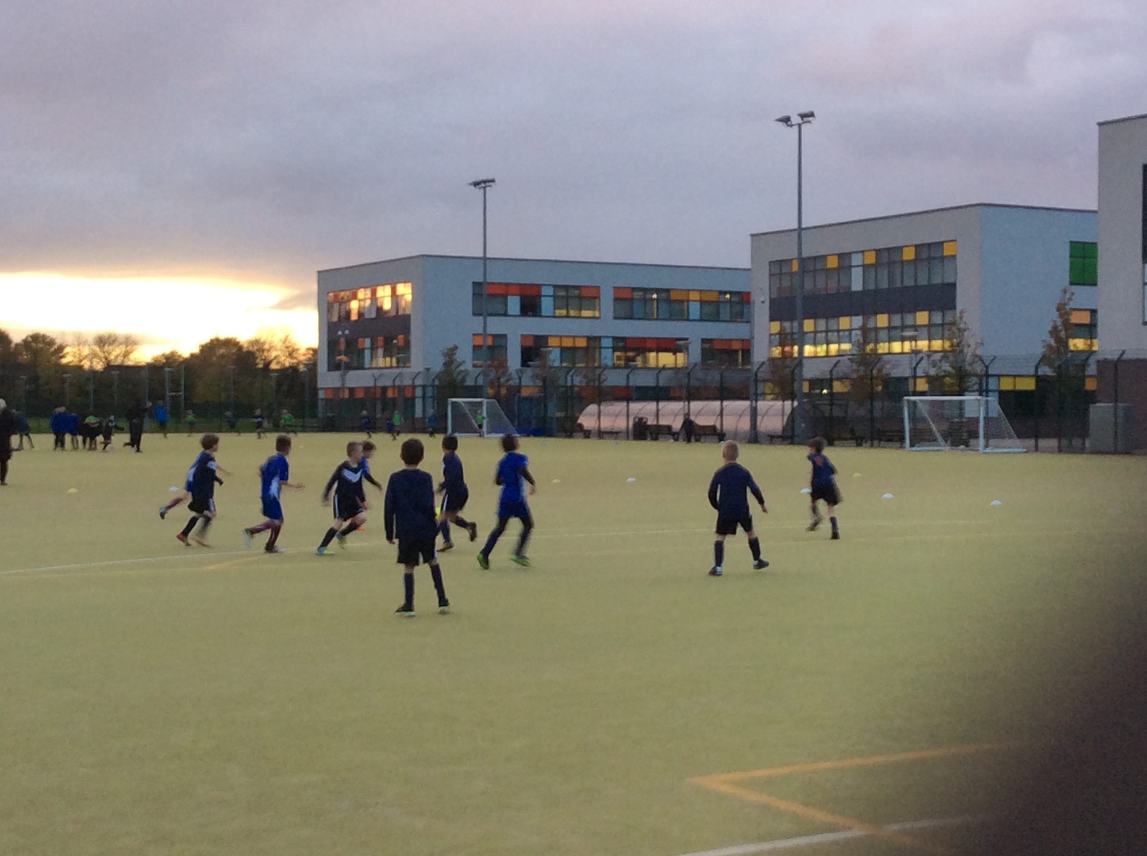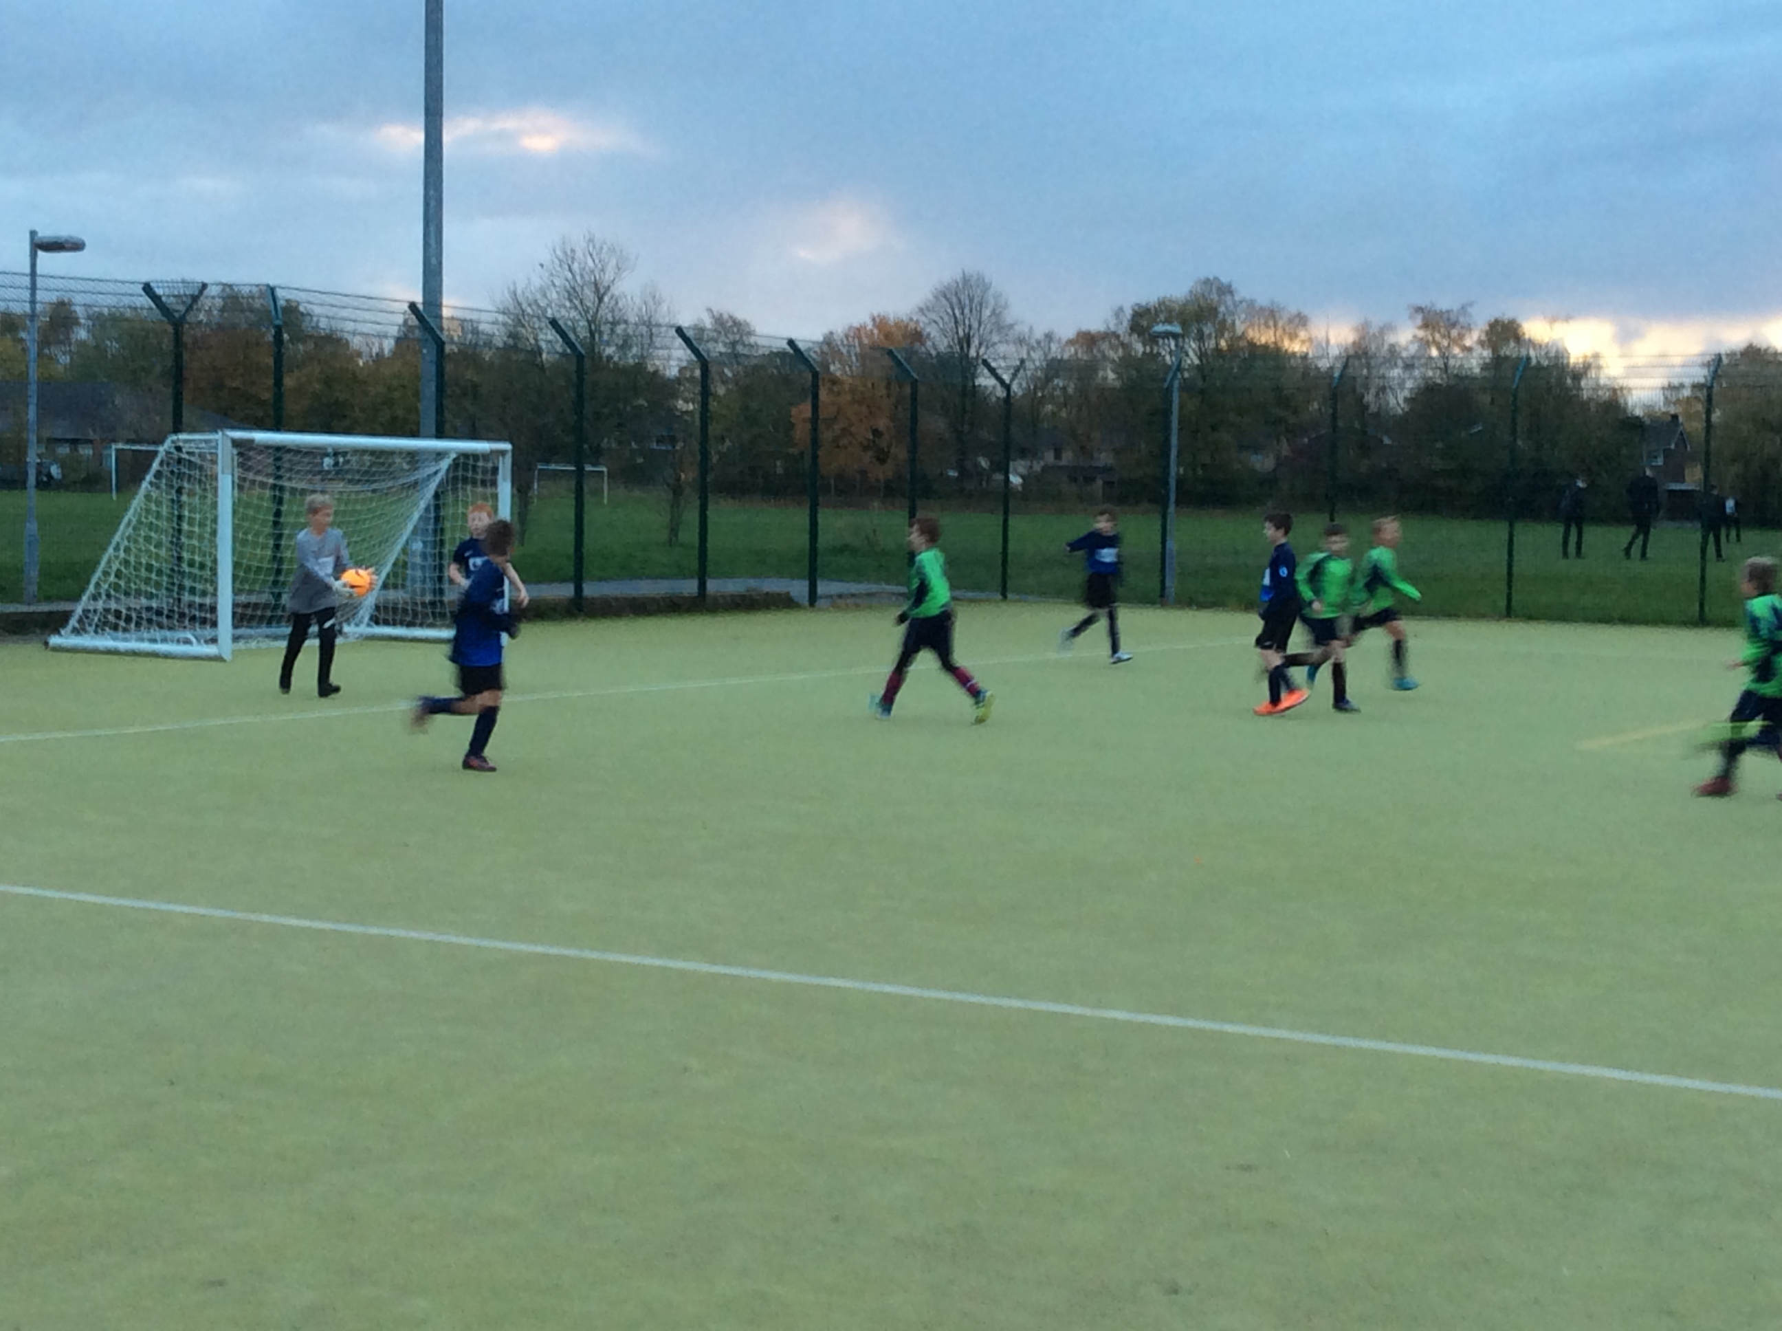

Year 4 and 5 Swimming Lessons

This year we have changed our swimming lessons from Irlam to the SWIM Centre in Warrington. This is a new, purpose built swimming centre in Warrington. The children in Y4 and Y5 are enjoying putting on their swimming caps and learning new skills.

PE Cluster Meeting

On the 11th October, Miss Lea attended the PE Cluster Meeting held at Callands Community Primary School. Around 15 schools were in attendance and we discussed how we can improve sport across Warrington. This meeting will be a regular half termly meeting, where PE Subject Leads can share ideas and discuss ways to improve sport in schools across Warrington.

Primary Sports Leadership Camp

During October half term, 5 children from Y6 were selected to take part in a sports leadership camp over three days at Priestley College. The children had the opportunity to experience a range of sports as well as learn how to lead sports activities back in school. The following sports were covered during this camp:

- Tag Rugby
- Sportshall Athletics
- Hockey
- Personal Challenge
- Dodgeball
- Gynmastics

The children are looking forward to the next camp in April.

Sara | Harry | Culcheth | F | 6 | Y | Y | Y
Kristians | Krastins | Culcheth | M | 6 | Y | Y | Y
Billy | Lawerence | Culcheth | M | 6 | Y | Y | Y
Dominic | Smith | Culcheth | M | 6 | Y | Y | Y
Ella | Wall | Culcheth | F | 6 | Y | Abs | Abs

November

Warrington Wolves Assembly

We have a great partnership with The Warrington Wolves Foundation and they made their first visit of the year to deliver an assembly to all of KS1 and KS2 on the 14th November. Will from Warrington Wolves talked to the children about the importance of perseverance and how having a positive attitude can not only help you in sport but is something that we should be doing all of the time. We are looking forward to their next visit.

KS2 Netball Match

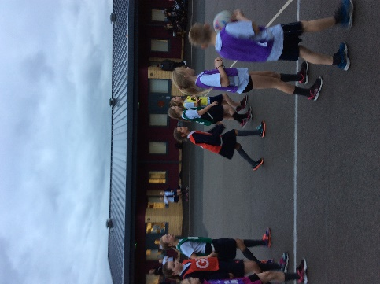
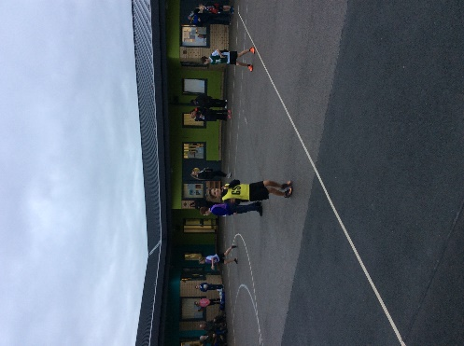
Our netball team made the journey to Chapelford Village Primary School for our first Netball friendly of the year on Tuesday 14th November. The children really tried their best and produced an outstanding performance winning 9-4. What a fantastic achievement, all of the children really enjoyed themselves despite the cold weather. We are looking forward to our next match.

Year 3/4 Football Match

On Tuesday 14th November our Year 3/4 Football Team took on Birchwood C of E in a friendly match. They all played extremely hard and brought home the victory for Culcheth, winning 6-2. The match was held at home on our school field. Congratulations team!

Year 5/6 Football Match

On Friday 17th November, the Year 5/6 Football Team welcomed back Birchwood C of E for another game, held on our school field. It was a very close game. With 1 minute to go the game was tied 3-3, and in the last 10 seconds Birchwood scored to take the match 4-3. The boys played extremely well and are looking forward to their next match.

Walton Gardens Cross Country Race 2

On Saturday 18th November, Mrs Rodgers, Miss Lea and 20 of our runners from Running Club attended the second of three cross country runs held at Walton Gardens. The runners and staff were praying that the weather would be better than it was for the first race. The children performed exceptionally. We had the most children running for our school out of the whole competition (the best turnout of all Warrington Schools). This particular race had 166 girls running and 170 boys running, this was the highest turnout ever for the race. Ella Wall came a very impressive 4th and Dominic Smith came an impressive 14th, improving on his 26th place finish in the previous race. Our girls’ team even made it into the Warrington Guardian Newspaper. Well done to all!

Global Learning Session and Staff CPD

On Monday 20th November, Years 2 and 3 had the opportunity to take part in Global Learning Sessions. The children in Year 2 looked at Earth Education, exploring the schools surroundings and looking at using their five senses to explore this. The children loved being outdoors, the particularly enjoyed making cocktails using materials from around school. The children in Year 3 were lucky enough to take part in some philosophy for children outdoors. They particularly enjoyed exploring the environment and recording their observations, by using chalk to write them down on the school playground. All children thoroughly enjoyed their time outdoors.

After school it was the turn of the staff, Mrs Dodd, Mrs Rodgers, Miss Lea, Miss Knowles and Miss Ball all attended the CPD Session focusing on Global Learning and Philosophy for children (P4C). The CPD session gave all the staff lots of ideas that can be trialled in class as well as a range of ideas for the upcoming Green Day. Mrs Rodgers particularly enjoyed playing with the mud in the school playground in an attempt to protect an egg. Further CPD will be provided on how we can use the outdoor environment and philosophy for children in conjunction with each other. This will be available to all staff in school.

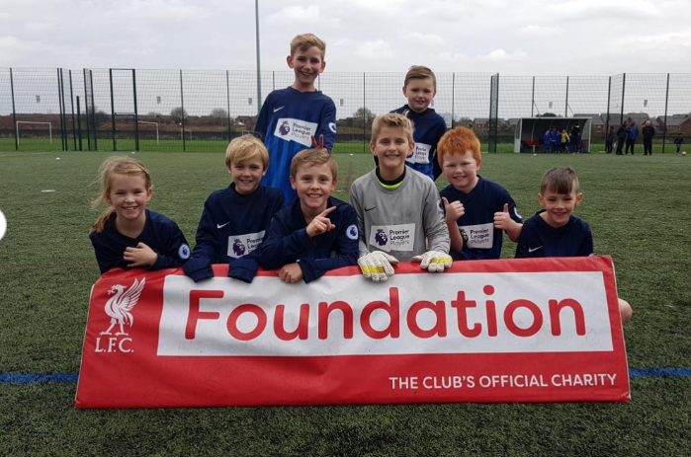
Liverpool Premier League Schools Football Tournament

On Thursday 23rd November, Mr Chesworth was very excited about taking a group of children to Liverpool Football Club in order to participate in a Premier League Schools Football Tournament. The matches were 6-a-side and played on the training pitches (astroturf). The children really enjoyed their day and loved the experience.

December

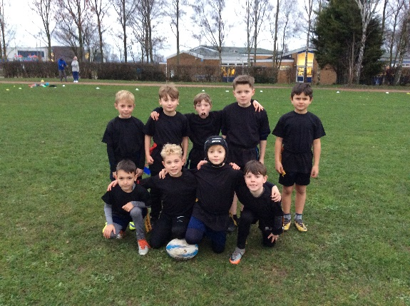
Year 3/4 Rugby Match

On Tuesday 5th December, our Year 3/4 Rugby Team played a nail-biting tag rugby friendly match against Chapelford Village Primary School. The boys played incredibly well and went home extremely muddy. We are looking forward to our rematch.

Walton Gardens Cross Country Race 3

On Saturday 9th December, our running team ran in the final Walton Gardens Race of the year. Both the boys and girls team performed incredibly with special mentions going to Ella Wall for coming in 15th and Dominic Smith who came in 13th place. Again, Culcheth Primary School were the most represented school at the event and despite the blizzard conditions the children represented the school extremely well. We are looking forward to next year’s Walton Gardens Event, but are looking forward to the remaining running event this academic year.
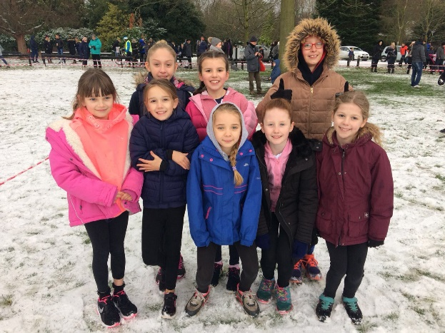

January

New Equipment

During the Christmas holiday we have had new equipment installed into the KS2 playground. They now have some gym equipment to play on during their break times and lunch times. This has been kindly funded by the PTA.

Commando Joe INSET Training
Staff have completed two twilight sessions where they have learned how to deliver the Commando Joe programme. We have looked at delivering the missions, using ICT and also looking at cross curricular links within the missions. We are excited to get started with the programme.

Commando Joe Sessions

For the next year, KS1 will be having Commando Joe sessions delivered by Commando Joe. The children will work through a set of missions which look at developing character. Each mission focuses on developing different character traits from respect to empathy to communication and team work. The children are very excited about these sessions. Commando Joe will also be running an 8am club on a Wednesday and an after-school club on a Wednesday which is already fully booked with a waiting list. We are hoping that this is going to be a success. KS1 children cannot attend the after-school or morning clubs, but KS1 teachers will deliver the Commando Joe’s missions and sessions to their respective classes.

Athletics Qualifier

A selection of KS2 children competed in an Athletics competition which was held at Culcheth High School. The children took part in track and field events and our Culcheth team qualified through to the Warrington Finals which will be held at Birchwood High School on the 30th January. The girls team won all of their races and overall, we came 2nd, having been beaten out of first place by 6 points by Twiss Green. We look forward to the rematch. We will be focusing on our field events in preparation for the Warrington Finals.

KS2 Football Match

Our Football team took part in a friendly match with Winwick Primary School. The children played on the Astroturf and they all played incredibly well. Unfortunately, the final score didn’t go our way this time, but the children showed exceptional sportsmanship and thoroughly enjoyed the opportunity to play a competitive game against another school. Great fun was had by all!

Athletics Warrington Finals

Our children competed in the Warrington Athletics Finals held at Birchwood High School. The team performed incredibly well, placing 8th overall. A fantastic achievement!

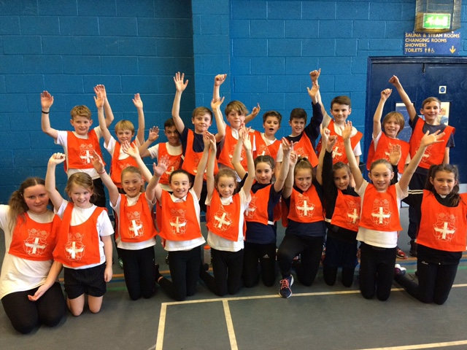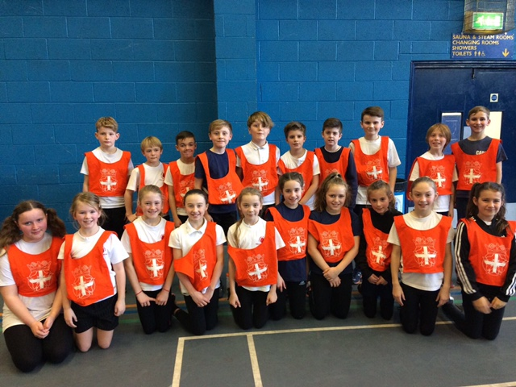

Well-being Staff Meeting

On Wednesday 31st January, staff took part in a wellbeing staff meeting. We looked at the benefits of keeping fit and healthy. We discussed how we can keep a healthy diet and exercise with our busy lives as teachers. All staff found this training useful.

February

Netball Tournament

Congratulations to our Netball Team, who came 2nd in the Culcheth Tournament on Monday 5th February. They have made it through to the Warrington Finals, which we look forward to competing in. Well done Mrs Lockwood and the Netball Team!

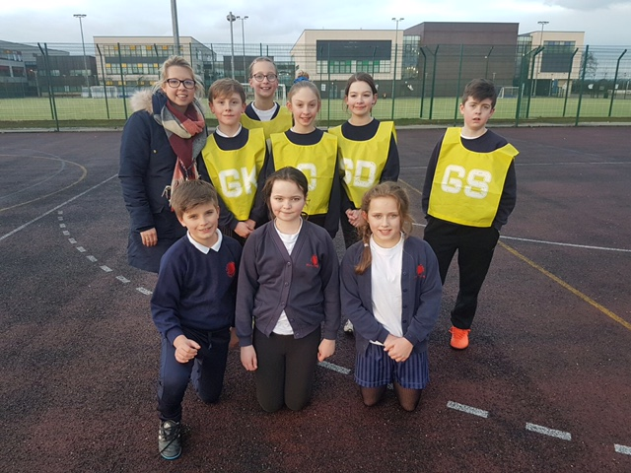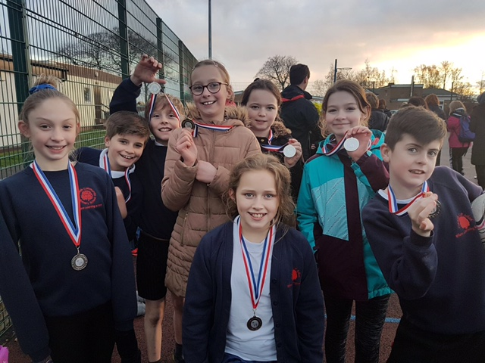

Cluster Meeting

On Wednesday 7th February, Hannah attended a cluster meeting for PE, held at Callands Primary School. Competitions were discussed and new friendly matches scheduled. We also looked at the recent update with Swimming, ensuring that all current swimming data is online and on your school website by April. We also looked at Sports Premium Documents and how to complete these so that they contain everything that is needed.

Tennis Roadshow

Reception and KS1 children have taken part in a tennis roadshow. They learned lots about controlling the tennis ball and also how to use a racket. All of the children had lots of fun and at the end were given certificates and invites to a local tennis event.

KS1 Girls Tennis

Throughout this half term, the girls in KS1 have taken part in Girls Tennis sessions. This program was designed to try to encourage more girls into the sport of tennis. The girls were asked to feedback on each session in order to help in the development of a new tennis programme specifically designed for girls. The girls had great fun and KS2 girls can’t wait for their sessions.

PE Network Meeting

On Wednesday 28th February, Hannah attended the second Network Meeting at the Halliwell Jones. Membership to livewire and School Games was discussed as well as competitions. A new program from Warrington Gymnastics was presented to us with further information to follow. It was a very interesting meeting, which has given Hannah the knowledge of current issues within sport in Warrington as well as upcoming deadlines and competitions within the LA.

March

Year 3/4 Tag Rugby Training

On Friday 2nd March the annual Warrington Wolves Rugby Training commenced for our Year 3/4 classes. The children are looking forward to the competition in the summer term and are really enjoying their rugby sessions.

Change 4 Life Year 1

Monday 5th March was a busy day in the Culcheth Sporting Calendar. Year 1 attended the Change for life Event at Priestley College, where they learned a lot about keeping and living a healthy lifestyle. They looked at different sports, diet and also mental wellbeing. They had a fantastic afternoon!

Netball High 5’s Warrington Final

Again, on Monday 5th March, Mrs Lockwood took the children to the Warrington Finals of the High 5’s Netball competition. The children came 3rd overall in Warrington, which is a fantastic achievement. They unfortunately have not made it through to the Cheshire Finals, however having come third they will be on the reserves list. A fantastic achievement, well done Netball Team.

Football Tournament Year 5/6

Congratulations to all the Year 5/6 Football team who attended the very first, Culcheth Primary School Football Tournament. The tournament was organised and ran by ourselves and was a huge success. Fantastic feedback has been given about the event, which we hope to make an annual tournament. The winners were Twiss Green Primary School – who took the trophy and the gold medals. Silver medals were awarded to Burtonwood and Bronze medals were awarded to Gorse Covert after a close penalty shoot-out! All children enjoyed themselves and everyone who attended received a certificate of participation. A great tournament, which Culcheth Year 5/6 team displayed great sportsmanship. Well done to all involved!

Skipping Workshop
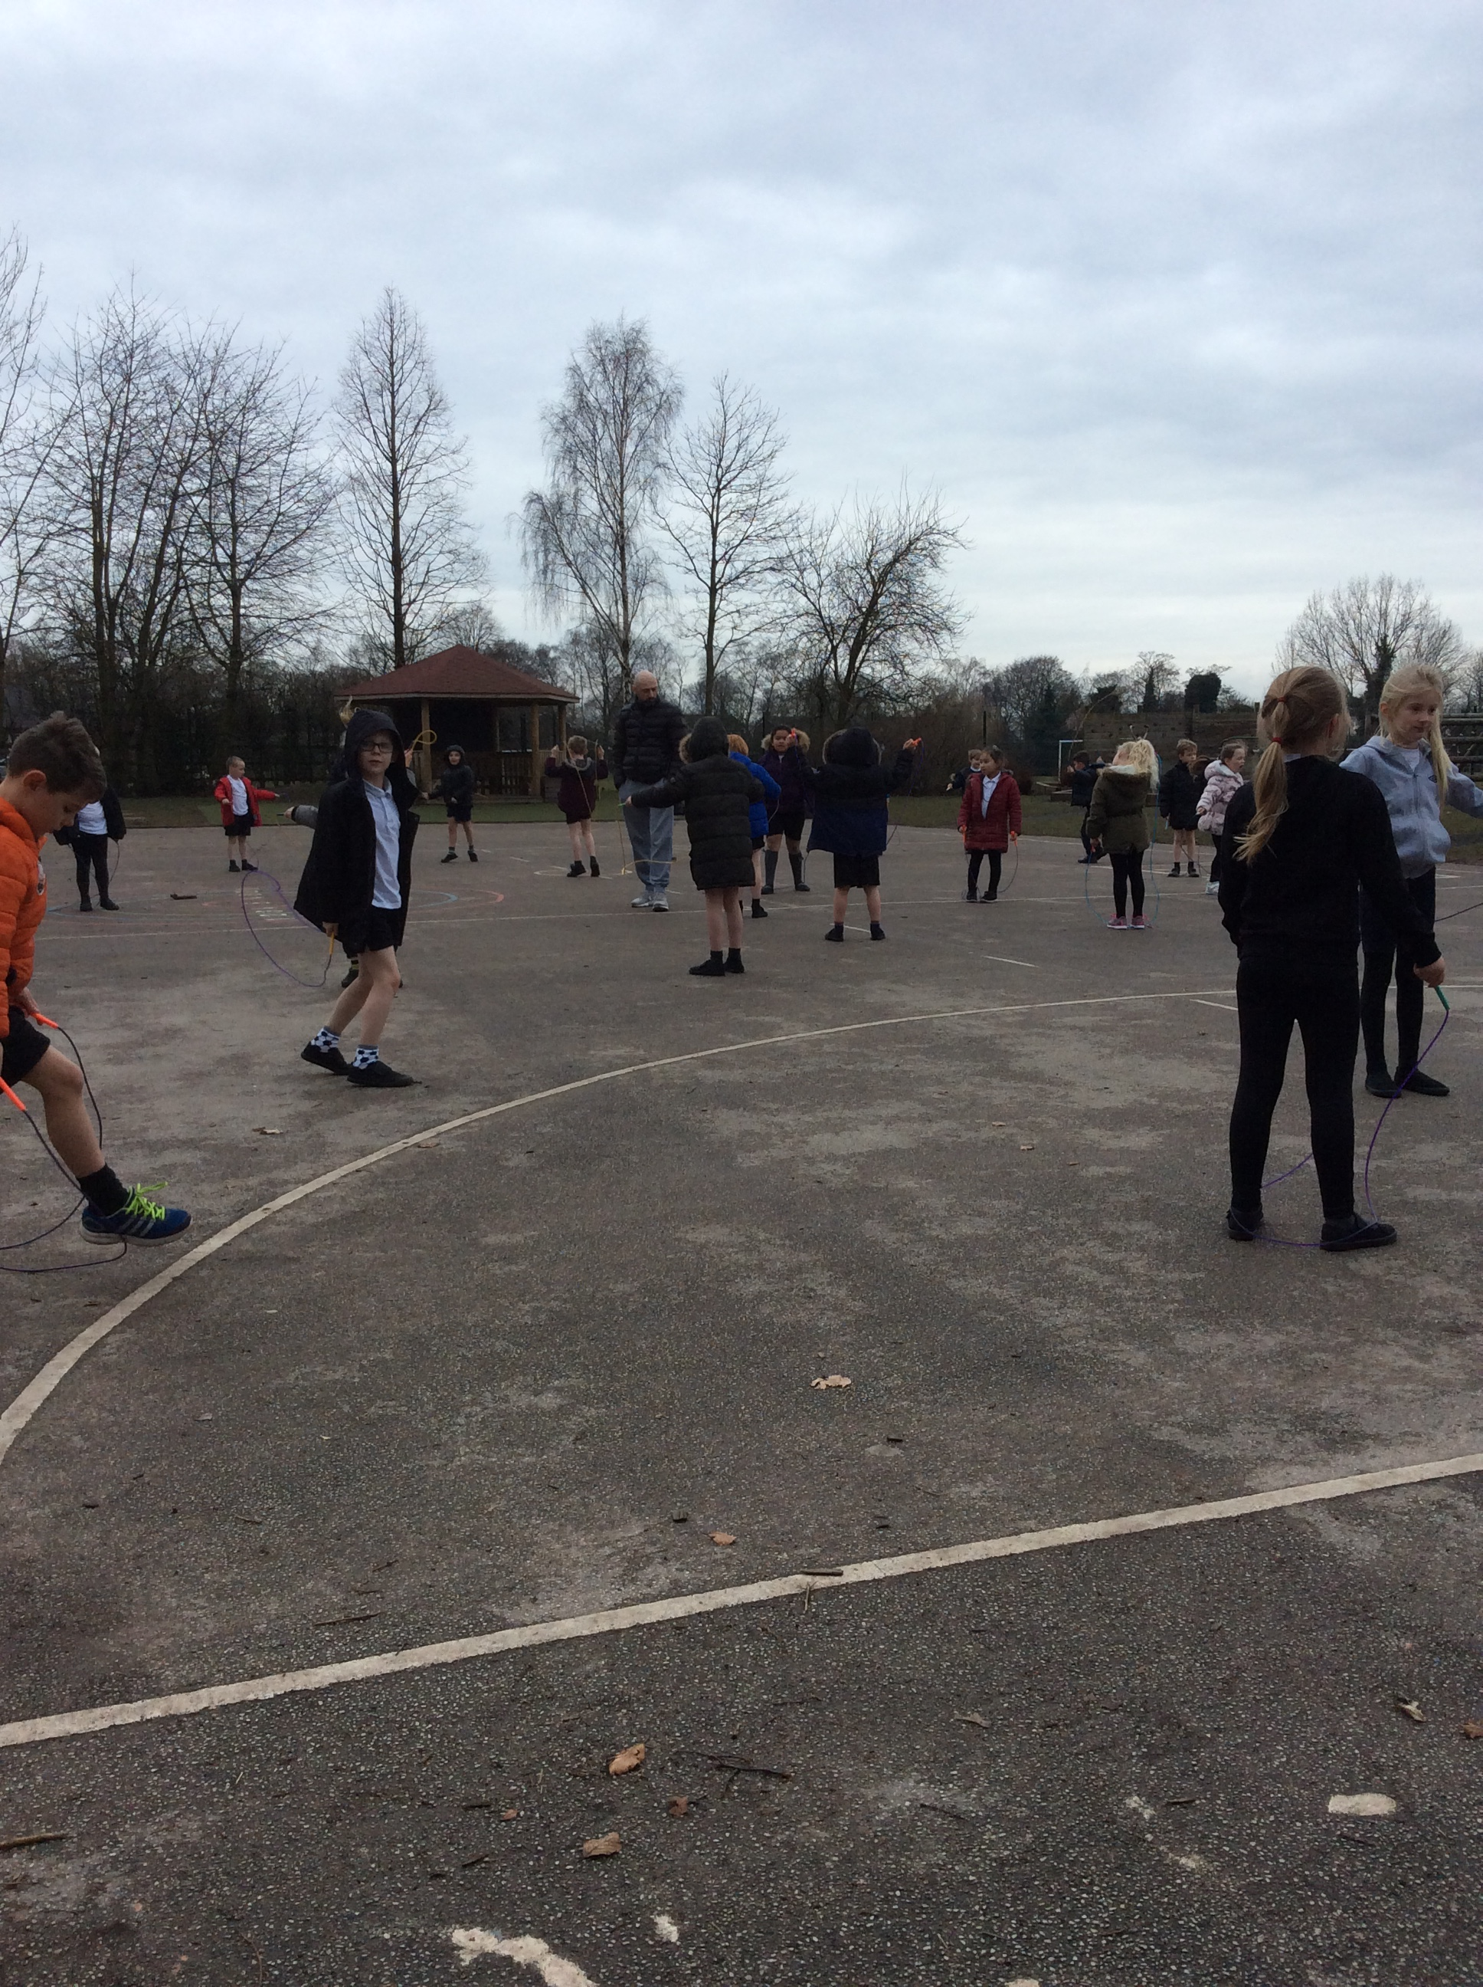
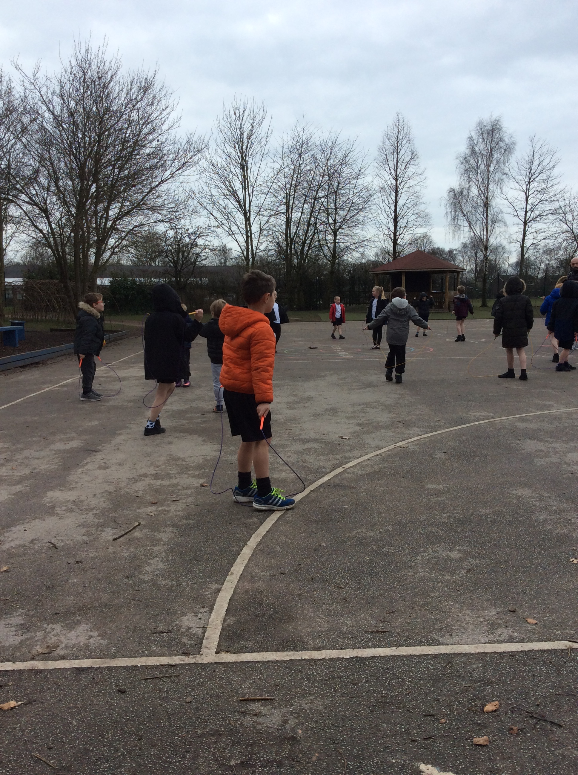
On Tuesday 6th March, Reception through to Year 6 took part in a skipping workshop. Each class learned a different type of skipping and shared them in the Sports Assembly in the afternoon. The children in each class will teach each other their skipping rhyme or style during lunchtimes and break times. Lots of children bought skipping ropes after the workshop from the school office and many of the skipping ropes bought were French Skipping Ropes. It was a fantastic workshop.

Tag Rugby Tournament

Our Year 5/6 Rugby Team took part in a super tournament at Warrington Sports Club on Tuesday 6th March. The team played incredibly well and have managed to make it through to the next round. We are awaiting a date for this, but we are incredibly proud of all of our Y5/6 Rugby players. Well done!

Year 5/6 Quick-sticks Hockey
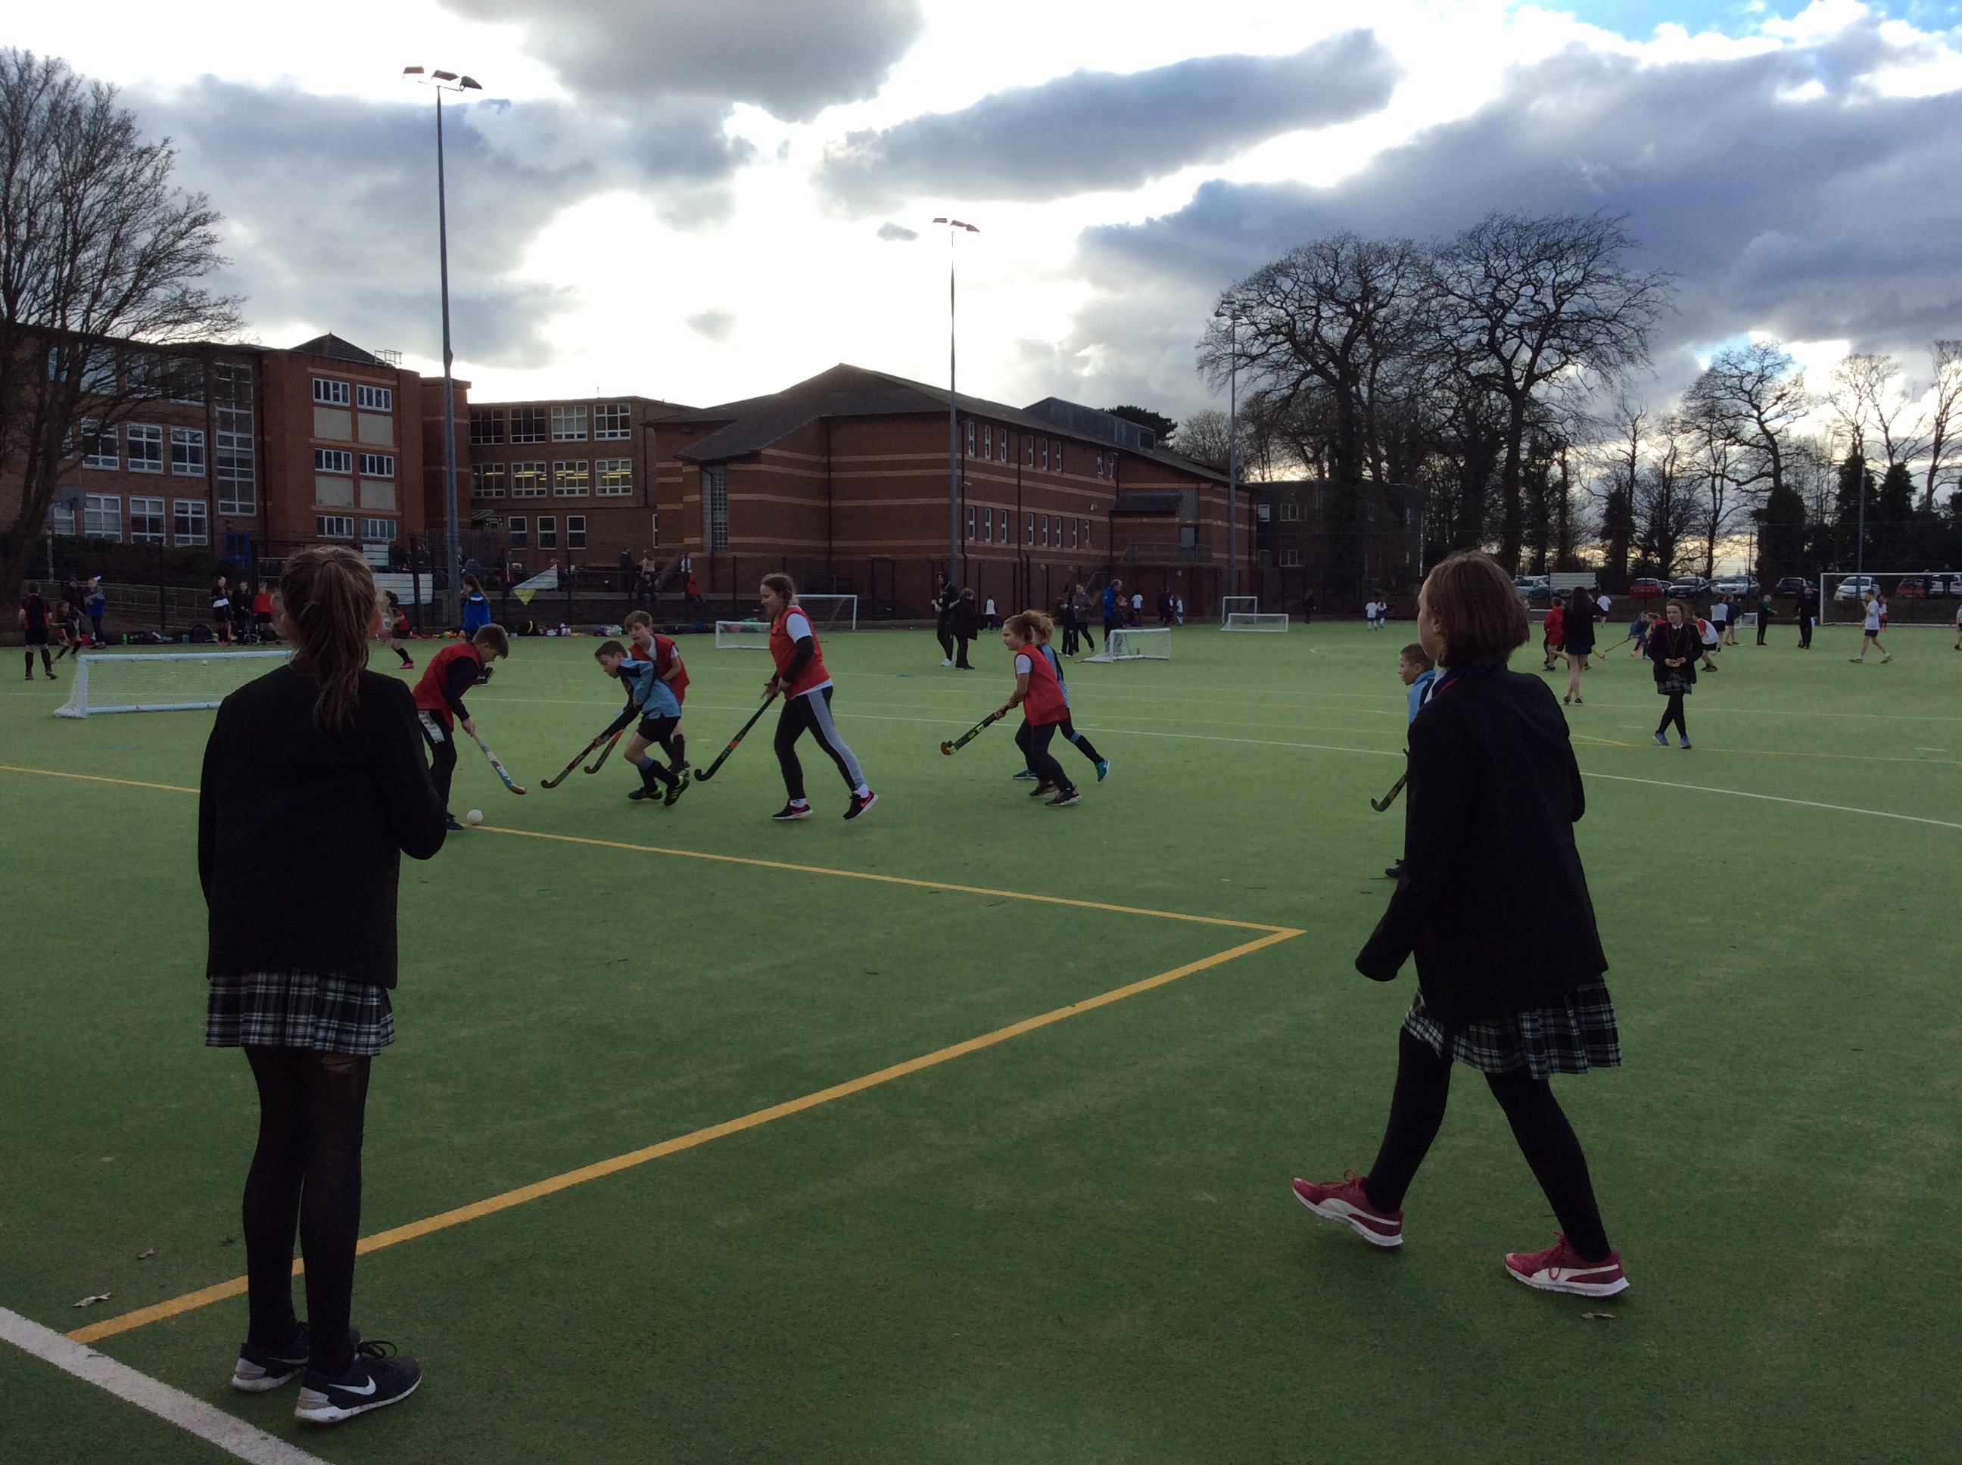
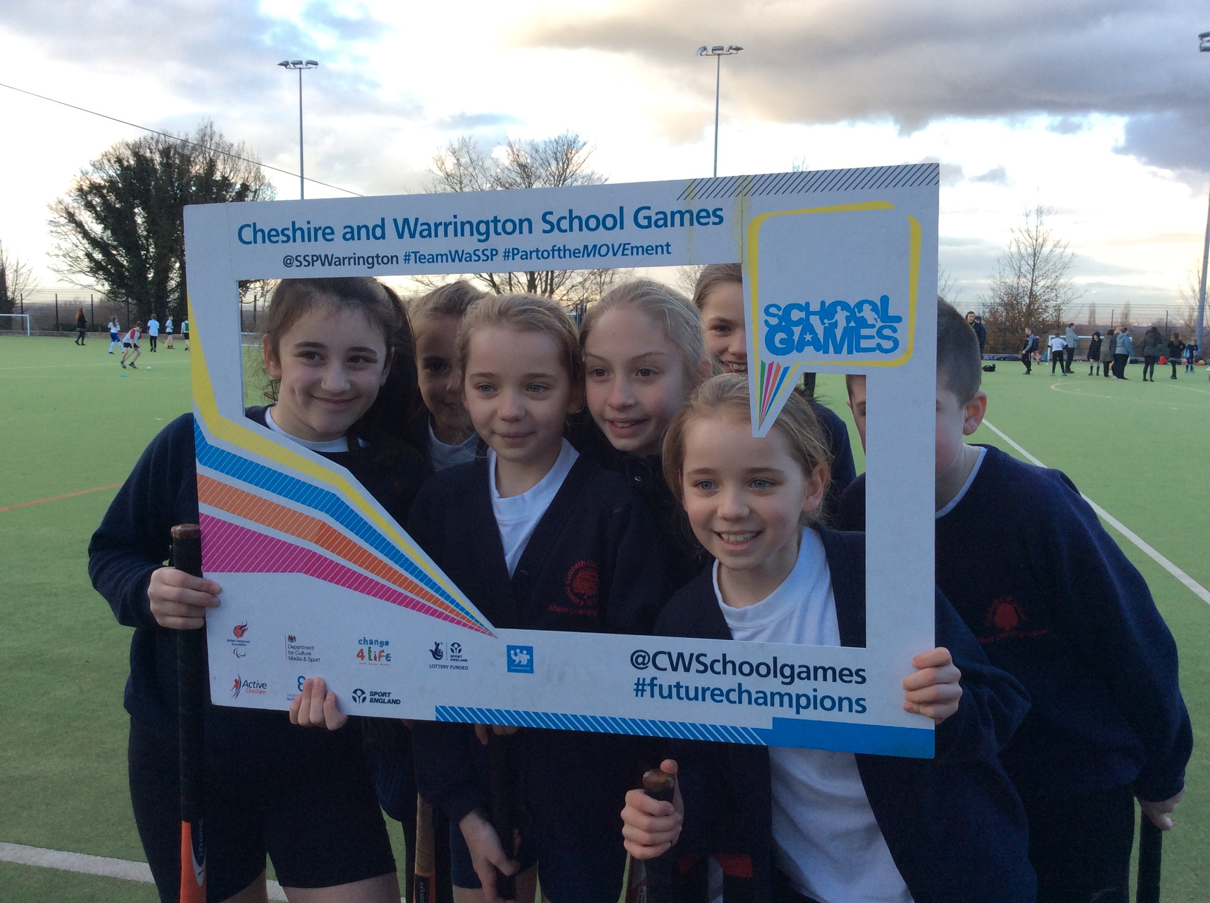
On Wednesday 7th March, we took 2 teams to the Lymm High School Hockey Qualifier. The children played incredibly well and really enjoyed themselves. Unfortunately, neither team made it through to the finals, but the main thing was that all the children had fun. Super teamwork and sportsmanship Culcheth!

Ability Day 2

On Thursday 8th March, children from KS2 attended the second ability day of the year. They took part in lots of sporting events and really enjoyed the day. The children took part in curling, cricket, tennis and multi-skills workshops. All children received a participation medal, which they were thrilled with. “It was such a good, I really enjoyed the curling” Ruby W Year 6.

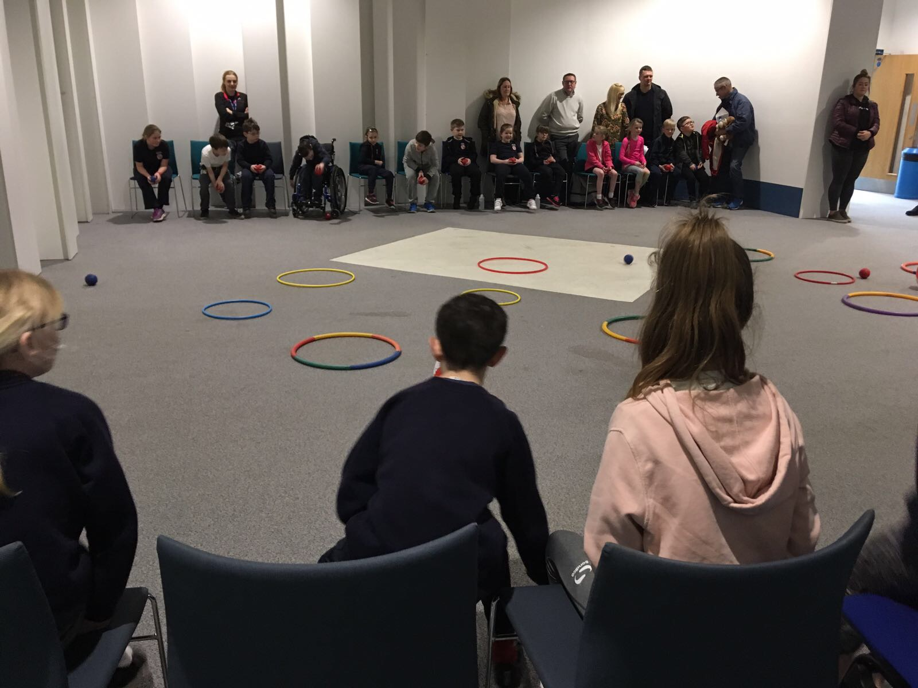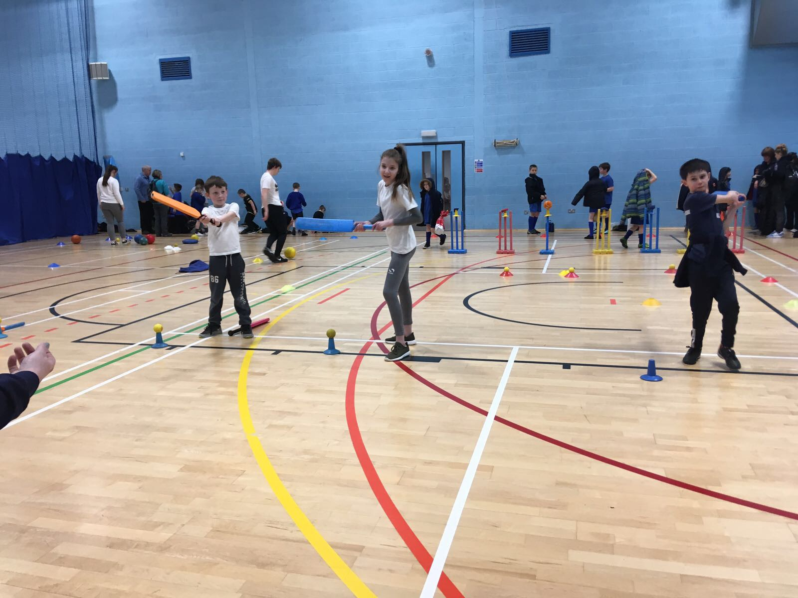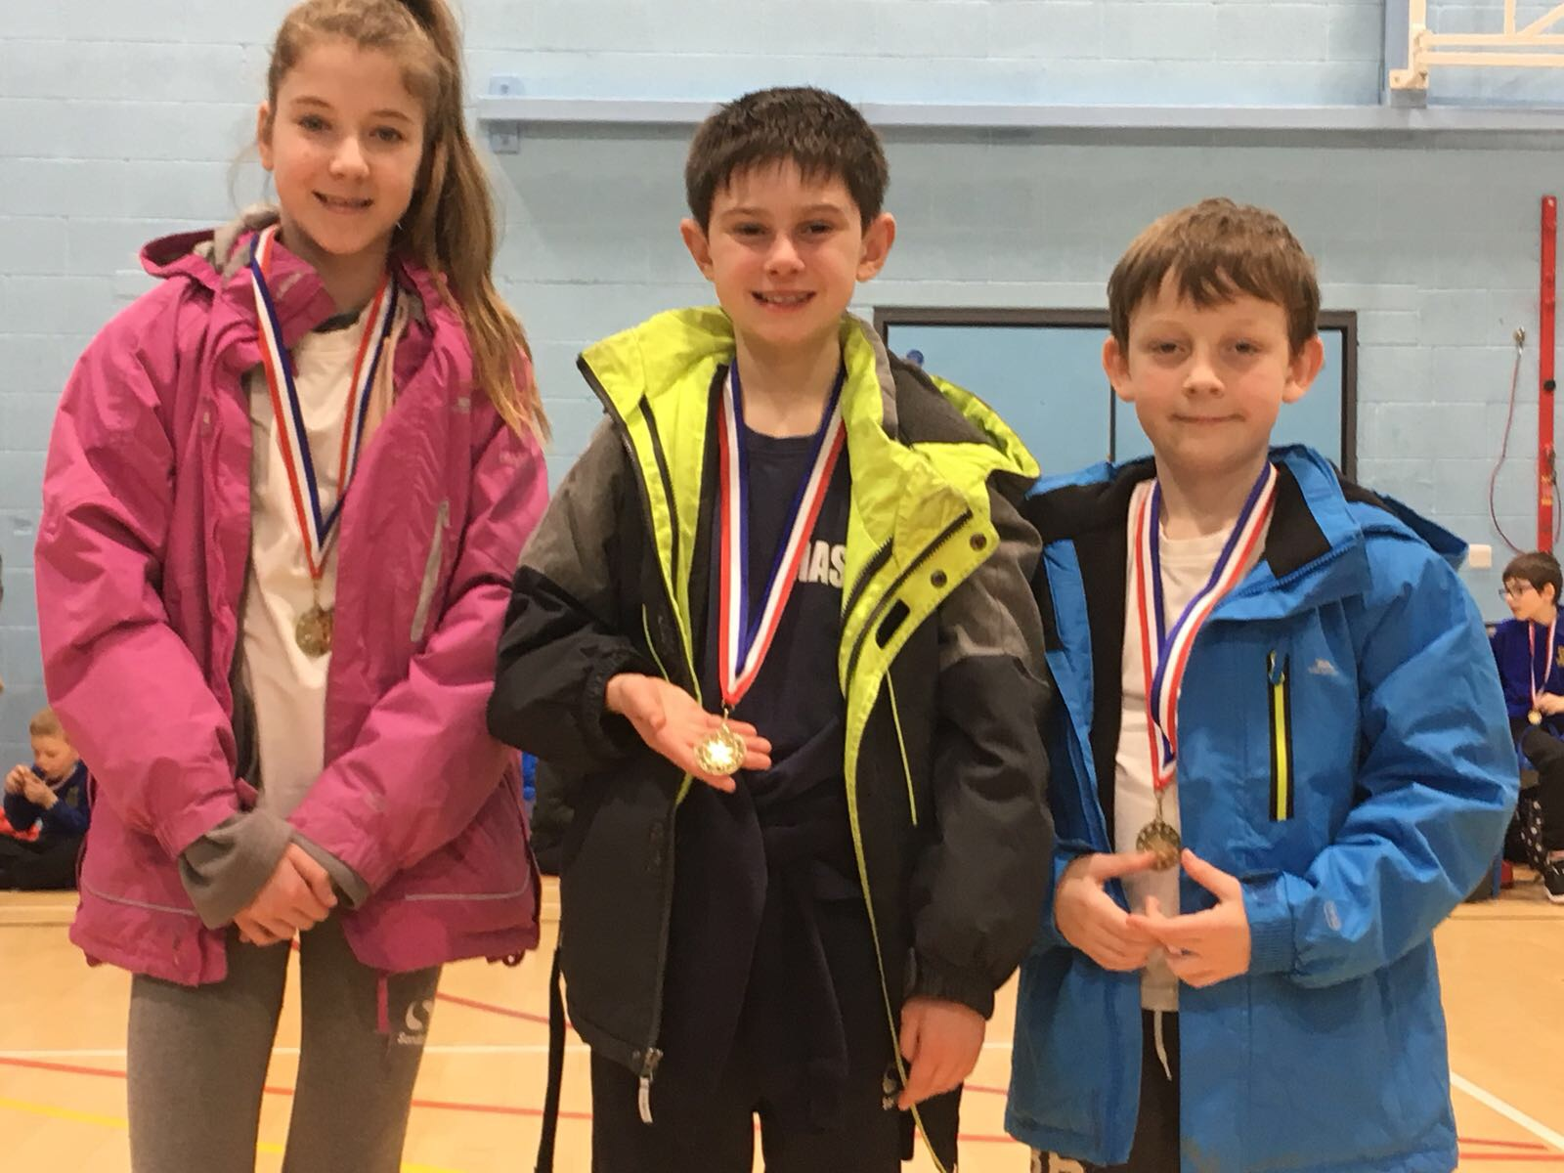

Change 4 Life Year 4

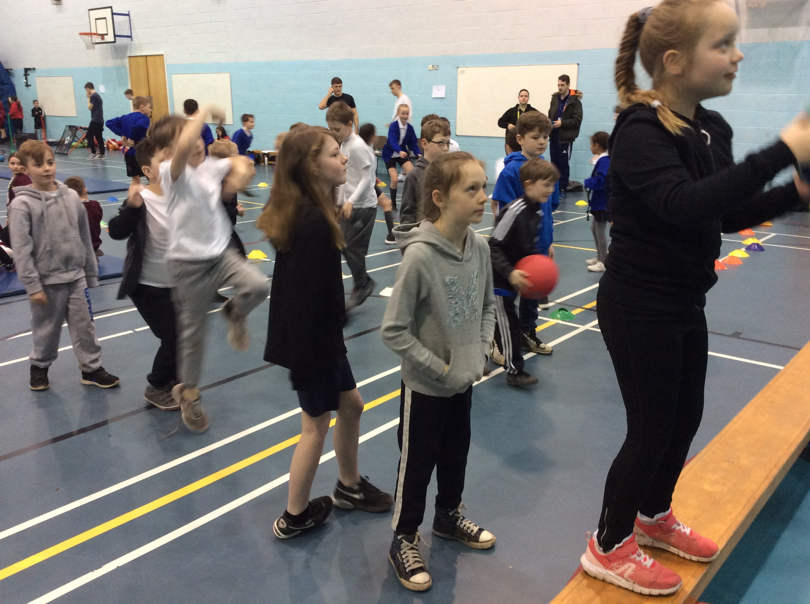
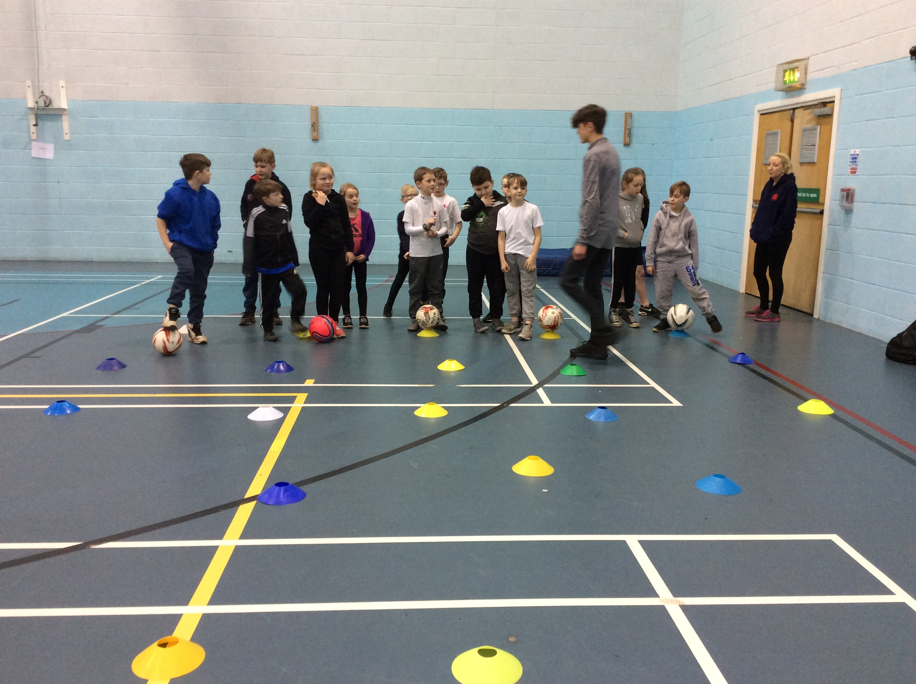
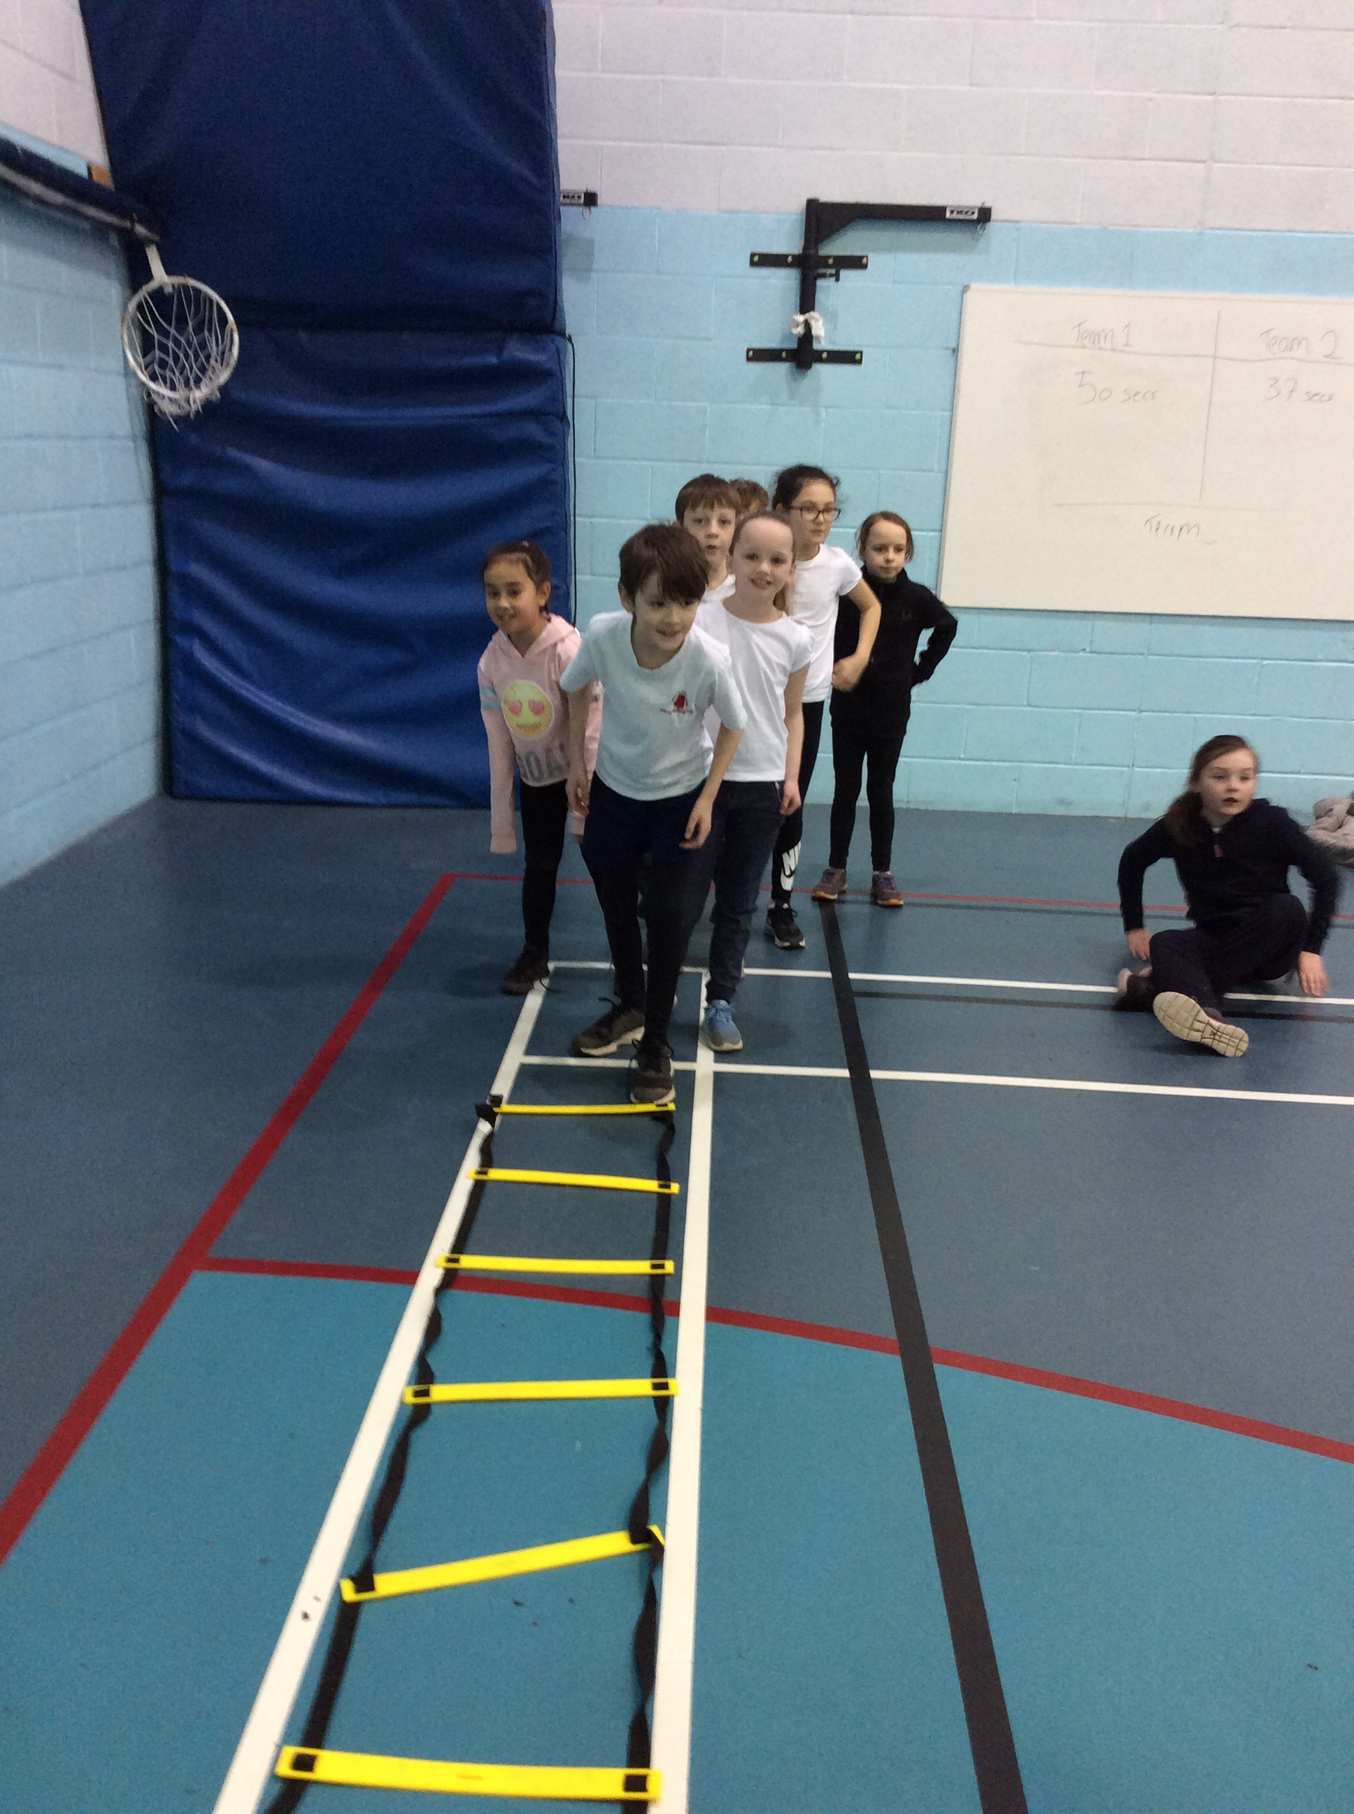
On Friday 9th March, our Year 4 class thoroughly enjoyed their ‘Change 4 Life’ afternoon at Priestley College. The children left school at 12.45pm and arrived back at school at 4.30pm. The children had a great time and took part in a variety of sporting activities based around participation in sport. There was a great emphasis on everyone being active and engaging and participating in sport and it was fantastic to see the children give it their all!

Football Tournament Year 1 and 2

On Monday 12th March, we hosted our second ever Football tournament, but our first ever KS1 tournament. It was a huge success! Despite the weather, we did not cancel and managed to play the tournament in the CHS Sports Hall thanks to their staff. Our football team played well and enjoyed playing lots of matches. St Peters won the trophy, with Croft coming second and Newchurch 3rd. We have had lots of positive feedback from the schools who attended and we are really excited about our final tournament for Y3/4 next week.

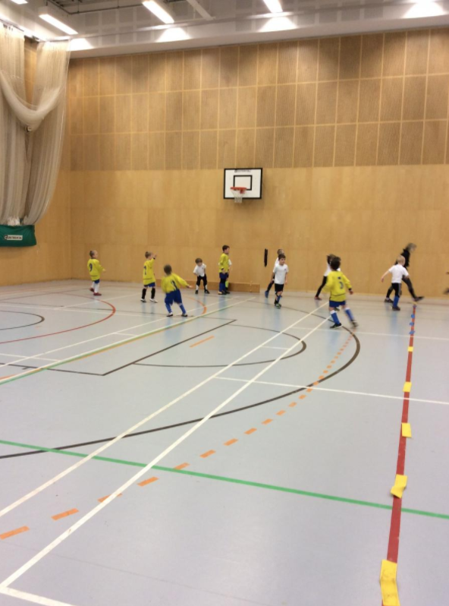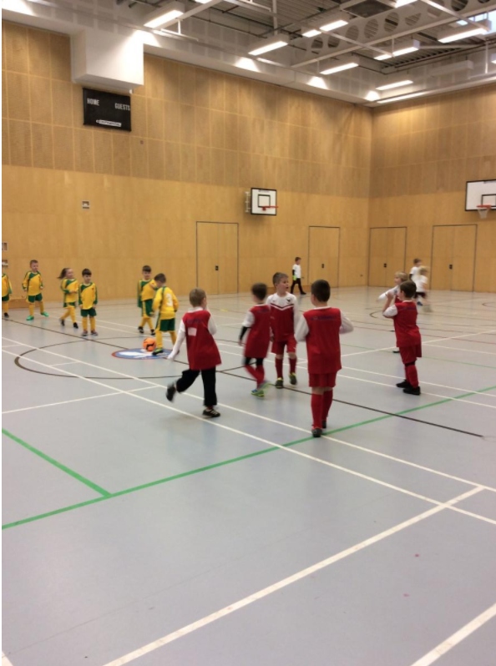

Year 5/6 Warrington Schools Basketball Tournament

On Tuesday 13th March, our Year 5/6 Basketball team played against a range of schools at The Ball Hall. The children played really well and took part in 4 matches. We won the first game 9-1 as well as winning the second game 5-2. Unfortunately, we lost our final 2 games against St Monicas and Chapelford. The children placed 3rd overall which is a fantastic achievement. All of the children received a certificate for their participation. We are currently reserves for the Warrington Finals next week.

Key Steps Gymnastics Year 5/6

On Wednesday 14th March our school took part in the Key Steps Gymnastics competition. We entered two individual competitors as well as a mixed team. Ella Wall in Year 6 won the overall individual event which is a fantastic achievement. Our mixed gymnastics team also performed well in all three disciplines. The children had a brilliant time!

Hockey Finals

On Thursday 16th March, our Hockey team made it through to the Cheshire Finals for Quicksticks Hockey. The children played incredibly well and enjoyed their time playing different schools across Cheshire. The children were treated to great facilities at The Hockey Centre in Alderley Edge. The children came 7th overall which was a great achievement. Well done team Culcheth.

Year 3 Football Match vs Gorse Covert

Also on Thursday 16th March our Year 3 Football Team played a match against Gorse Covert Primary. The team played incredibly well, with the final score being 5-2 to Culcheth. We are looking forward to the tournament on Monday and future friendly matches.

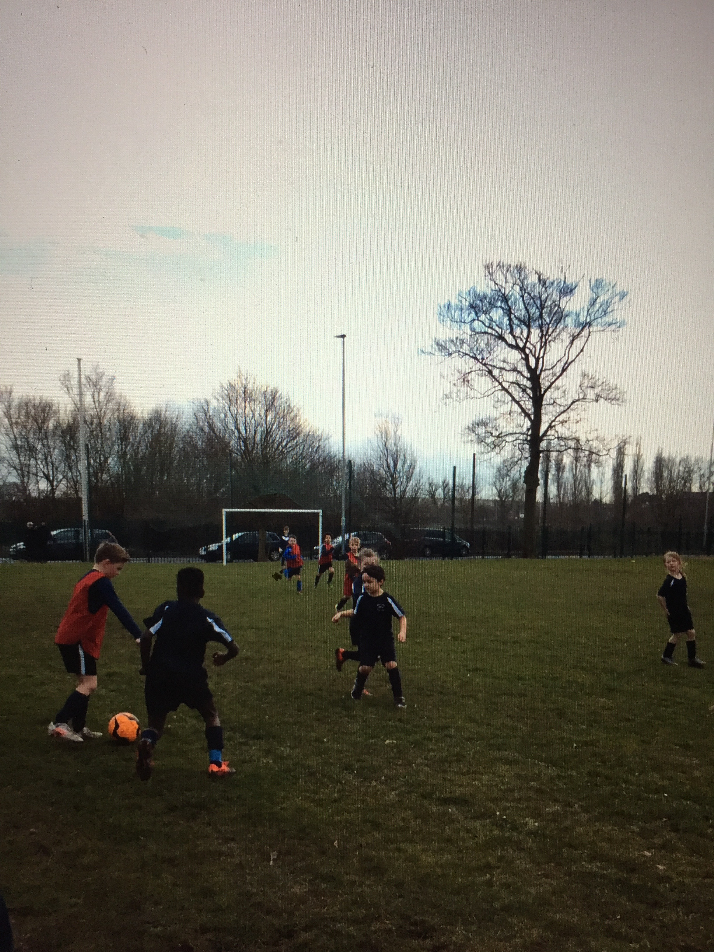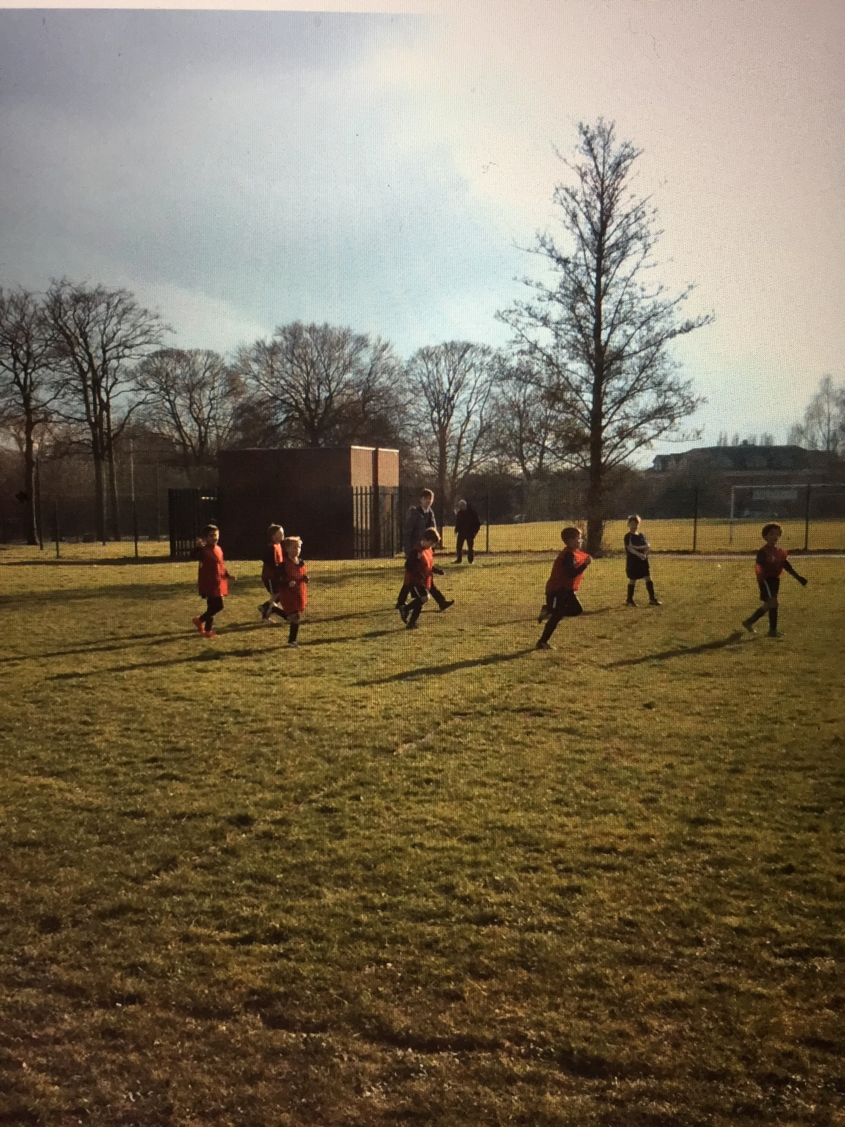

Year 5/6 Netball Match vs Gorse Covert

While the Year 3’s were playing Football, the Year 5/6 Netball teams were playing over on the MUGA. Both of our teams played well drawing against Gorse Covert. We look forward to more friendly matches between the two schools.

Sport Relief

Our children have had a fantastic week for Sports Relief with all classes taking part in challenges each day, from hula hooping to dance. The children have had a great week. A big thank you also goes to Miss Green, the music teacher who has taught the children the Sport Relief song. It sounded fantastic in commended assembly on Friday and all of the staff loved the actions to go with it! Sport Relief ran from Monday 12th March to Friday 16th March.

Year 3/4 Football Tournament

Monday 19th March was the date that our final Football tournament organised and hosted by our school was held. The Y3/4 team played incredibly well and the feedback from the tournament has been incredible! It was the final football tournament of the year hosted by ourselves. Broomfields won, with Winwick in 2nd and Gorse Covert in 3rd. Super effort from all teams and schools.

Key Steps Gymnastics Year 1/2

4 of our Y1/2 children attended a gymnastics competition held at The WIRE Gymnastics Club on Tuesday 20th March. We entered 1 team and the girls did incredibly well performing a floor, vault and body management routine. Pippa Wall in Y1 placed 3rd overall which was a fantastic achievement, but all girls did so well in their first ever competition representing Culcheth Primary School. You were superstars!

Cluster Meeting

On Wednesday 21st March, Hannah attended a cluster meeting for PE, held at Callands Primary School. Competitions were discussed and new friendly matches scheduled. We also looked at moderation and how we would go into a lesson to observe. We looked at the key points that we would look for when completing an observation.

Year 3/4 Tag Rugby Festival

Following on from our Year 3 and 4’s Rugby Training, the children participated in a tag rugby festival on Shaw Street along with 6 other local schools. This festival was held on Tuesday 27th March and despite the terrible weather, all of the children had fun. Unfortunately the festival did have to be abandoned at 1pm due to the weather, but all of the children had great fun getting muddy and playing rugby.

