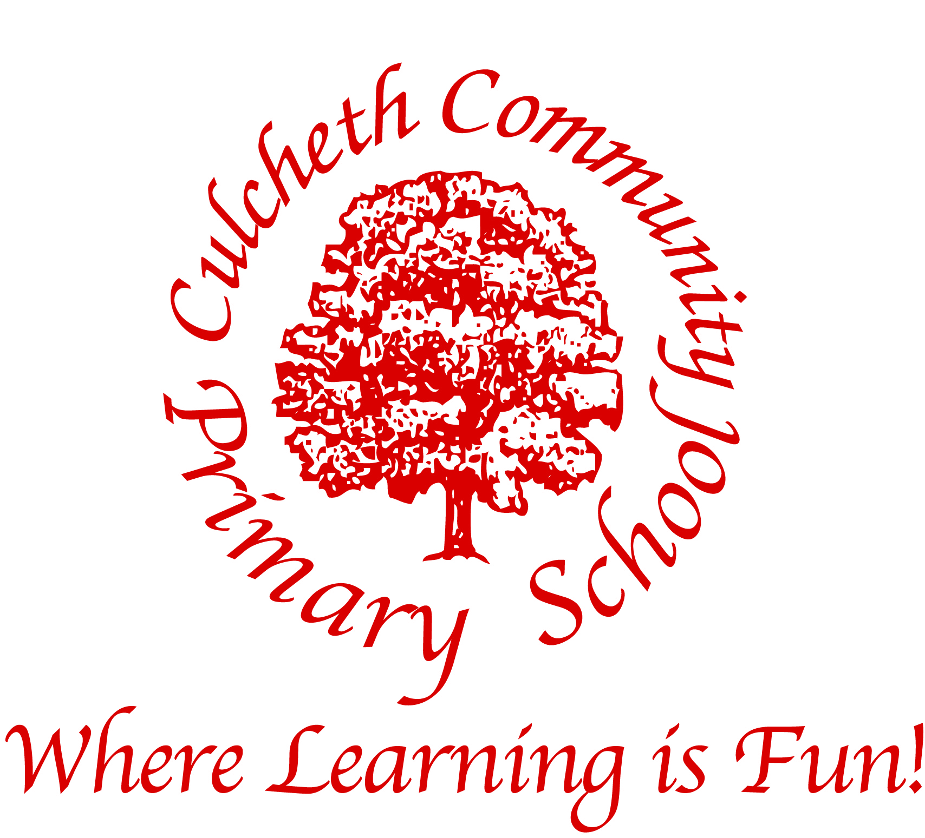

Culcheth Community Primary School

Warrington Road, Culcheth, Cheshire
WA3 5HH
t: 01925 764312 f: 01925 764690
e: culcheth_primary@warrington.gov.uk
www.culchethprimary.co.uk

Dear Parents,

On behalf of all the children, staff and Governors I’d like to offer a warm welcome to Culcheth Primary School.

We are extremely proud of our pupils and all of their achievements, and especially proud of the strong commitment and partnership between Governors, staff, parents, children and the wider community. We invite you to join us in this partnership between home and school, knowing that by working together we can provide the best for every child. Together we can ensure a quality education which enhances children's learning and growth in a safe, challenging, happy and caring environment.

We aim to provide a broad, balanced and engaging curriculum which both fulfils the National Curriculum requirements and meets the needs of each individual child. We aim to bring learning alive, making it stimulating and exciting.

If you would like to find out more and wish to see the school at work, you will always be made very welcome. Visitors always comment on the friendly welcoming atmosphere in school and the excellent behaviour of our children – we look forward to meeting you.

Kind regards,

Mrs A Dodd

Headteacher

Where learning is fun

Our Staff Team

Headteacher

Mrs Dodd

Assistant Headteacher

Mrs Rodgers

Family Support Worker

Mrs Lynskey

Teaching Staff

Mrs Smith
Mr Chesworth
Miss Wardle
Mrs Kenny
Mrs Lockwood
Mr Williamson
Miss Oldbury
Miss Knowles
Mrs Gorman

Office Team

Mrs Lea
Mrs Willett

Kitchen Staff
Ruth Jones (Cook)

Midday Supervisors

Mrs J Leeming
Mrs White
Mrs C Leeming
Mrs Isles
Mrs Atkinson
Mrs Booth

Site Manager

Mr Thornton

Teaching Assistants

Mrs Daintith
Miss Jones
Mrs Baldwin
Mrs Deakin
Mrs Atkinson
Mrs White
Mrs Ball

Governing Body

Mrs Bell (Chair)
Mrs McCreedy (Vice Chair)
Miss Harrison
Mr Bland
Mrs Smith
Mr Simpson
Dr Hall
Mrs Michaelas
Mrs Lea

Governors are similar to a Board of Directors who make decisions about how the school is run and about future strategic direction.
They decide how the school budget is spent; interview and select staff, decide on the school curriculum and work on the School Improvement Plan with the Headteacher and the Leadership team to help to move the school forward.

Governors serve for a term of 4 years.

Full Governor meetings are held once a term. Committee meetings for curriculum, personnel, health and safety, finance and buildings are held once or twice a term as required.

Where learning is fun

Educational aims for our school

- To develop excellent attitudes and behaviour
- To feel safe and valued as part of a caring school community that celebrates success
- To enjoy learning and develop a passion to be life long learners
- To develop learners with ‘enquiring minds’ who feel confident to ask questions
- To encourage all learners to develop their full potential
- To foster respect for others and an appreciation of the world in which we live

Admission

Culcheth Primary is a community school for girls and boys from 4-11 years of age. Warrington Borough Council co-ordinates admissions to our school. Our published admission number is 30 per year group. Should this number be exceeded the Local Authority applies the following criteria when offering places:

- Children in care
- Siblings in school
- Proximity to school

Secondary School Transfer

The current admission criteria for Culcheth High School are:

- Child in care
- Siblings
- Proximity to school

Organisation

Our school has seven classes, starting with Foundation class followed by Y1 – Y6. Foundation, Y1 and Y2 are known as Key Stage 1 and Y3-Y6 are Key Stage 2.

Where learning is fun

We do not have any mixed age classes.

Each class has at least one teaching assistant.

Times of School

Morning school 8.55am - 12.15pm KS1
8.55am - 12.30pm KS2

Afternoon school 1.15pm – 3.15pm KS1
1.30pm – 3.15pm KS2

Children are allowed to arrive at school from 8.30am. The school doors are opened at 8.40am.
Registration takes place at 8.55am and at 1.30pm.

Children in Key Stage 1 are collected from their classroom at the end of the school day.
Y3 and Y4 are escorted to the front of the school by their teacher. Y5 and Y6 leave independently.

When dropping off or collecting your children, you may use the large car park in front of the Day Nursery. Please consider the safety of the children and drive with care and park considerately. At times the car park can become very busy; however we request that there is no parking on the road near the crossing as this presents a hazard to pedestrians. Alternative parking can be found on Shaw St car park or Withington Ave.

Before/ After School Care

This is provided by Culcheth Day Nursery which shares our school site. We recommend that you reserve places when you are allocated a place at school as demand for wrap around care can be high.

The Nursery can be contacted on 01925 767615.

Uniform

Grey skirt/pinafore/ trousers
White polo shirt with logo
Navy sweatshirt/ cardigan with logo
Plain socks
Black sensible shoes (boots/ trainers may be worn outside)

In summer a navy blue and white checked summer dress may be worn.

Your child will also need a book bag and a PE bag.

PE kit

Black/navy shorts
White PE shirt with logo
Black pumps
Tracksuit/ trainers for outdoor activities as advised by class teacher (any plain design)

The uniform with the school logo can be purchased online from Tesco, Touchline (just off A49 Warrington) or from Warrington Uniform Supplies in Warrington town centre.

Please can all clothes be labelled with your child’s name.

Nail varnish is not allowed.

Extreme hairstyles such as Mohican, shaved stripes or coloured sections are not permitted.

Jewellery

The Governing body requests that small plain stud earrings and a plain watch are the only forms of jewellery worn in school.
Earrings must be removed for PE.

Medicines in School

Medicines will only be given in school if they are prescribed by a doctor, brought into school by a parent with written instructions for use. This then constitutes formal permission.

Where learning is fun

School Meals

Lunch is prepared on the premises and served in the school hall. All meals meet the Government’s strict standards and are nutritionally analysed. All Infants are given a free school lunch. For Juniors there is a £2.20 charge per child, per day.

School operates a daily pay system, which allows total flexibility to choose between bringing a packed lunch and having a meal provided by school.
We also operate a direct debit system if you prefer to opt to always have school meals.

We are a healthy school and try to encourage healthy eating. We will encourage your child to try a taste of new foods and encourage them to eat fruit and vegetables. We ask for your support in this if your child brings a packed lunch and request that their lunch is as healthy as possible. If you need any inspiration for ideas, please speak to the school office. Sweets are not allowed in packed lunches.

We are able to cater for any special diets or food intolerances and will arrange a meeting with the catering staff if this is required.

Snacks

School provides a snack of toast/ crumpets in the morning with the choice of juice or milk. We ask for money for the week to be sent in on a Monday – currently this is £2.50.

If you would prefer to bring a snack from home, we ask that it is a healthy snack bar, fruit or yoghurt. Sweets are not allowed.

Water

We have fresh filtered water machines in school. Every child is encouraged to have a labelled water bottle and to drink regularly.

Smoking

We are a totally non-smoking site. This covers all of our school grounds including the field areas and car parks.

Curriculum

We offer a rich, engaging curriculum, which is taught in a cross curricular way wherever possible. Topics start with a pre-learning assessment, where the teacher finds out what the children already know and what they would like to learn about in the topic. We plan an exciting start to each topic, which may be a trip or visitor and finish each topic with a special activity, such as an assembly, making a film or book about the topic or making a mini museum for other children to learn about the topic.

Core subjects

English

English is taught daily, with a strong focus on developing phonics, early reading skills and writing through the Foundation Stage and Key Stage 1.
We focus on developing literacy skills across the whole curriculum.

Mathematics

Mathematics is taught daily. We use investigations, problem solving and mathematical challenges to develop children’s ability to apply maths skills

Science

We aim to develop children’s enjoyment and interest in science and build on children’s curiosity through a range of planned investigations and practical activities.

Computing

ICT is used as a learning tool throughout the curriculum via interactive whiteboards in each class, WiFi throughout school, visualisers in classrooms and voice recorders, to name a few of our available resources.

Where learning is fun

RE
RE

RE
We follow the Warrington agreed syllabus for RE. As stated in the 1988 Education Act, parents may request that children are withdrawn from lessons on religious grounds.
Children learn about the teaching of different faiths, developing a tolerance, respect and understanding for the beliefs of others.

Foundation Subjects

Music
We have specialist music tuition through school; music is rich and exciting. We are a Music Ambassador school for Warrington and share our expertise and enjoyment of music with other schools. We are also part of the Sing Up project and have Silver Level accreditation.

Art/ Design and Technology
We provide a rich, stimulating environment to encourage children to communicate and experiment with the use of colour, texture, form, pattern and materials.
We enjoy a special Arts Week to celebrate the skills that we have learnt and to inspire children by using the skills of professional artists to work alongside us.

PE
We are a ‘Healthy School’ and each child receives at least two hours a week of quality PE. In addition to the wide range of activities offered in school, we offer after school activities such as football, cross country netball and rounders and participate in inter-school competitions and tournaments.

Modern Foreign Languages
We teach French from Foundation stage. We have a specialist native French speaking teacher.

Humanities
History and Geography are taught through topics using an enquiry based approach to learning.

Extra-curricular activities
After school activities

We offer a wide range of clubs and activities after school. Most of these are run by our own staff and are provided free of charge. We offer clubs to children from Y1 as we feel that Foundation children become over tired if they stay at school for an additional hour of activity.
A letter detailing which clubs are available is sent out in September.

Residential Trips

Residential trips help to build friendships and to develop teamwork skills. We also find that they help to build self-confidence, resilience and encourage independence.

Y3 visit Burwardsley for a one night stay linked to their topic work.
Y4 visit Beeston Castle for a two night stay – also linked to their topic work.
Y5 and Y6 have activity based adventure based team building residentials.

Themed Days

We hold regular themed days through the year. Our regular days include:

Green Day – a whole day devoted to Eco-projects. We became the first ‘Eco-school’ in Warrington in 1997.

Decoration Day – a day off timetable where we split into mixed age groups to make and design Christmas decorations to decorate our school for the Christmas period. This is the start of Christmas for us!

Arts week – usually 4 days devoted to the Arts- art, design, drama, dance and music. A range of activities and specialist teachers come in to work with classes.

We also hold special themed days for any current events such as The World Cup or Commonwealth Games etc.

Where learning is fun

Parents in School

We have an Open Door policy – you will always be made very welcome in school. Please do contact school or speak to anyone if you have any worries or concerns as they are often very easy to solve if we are aware of them.
If you require an appointment to meet a teacher or the Headteacher, it is helpful if you phone in advance to check availability.

We ask that all children and their parents sign our ‘Home/school agreement’ so that we are all working in partnership.

You will be invited to attend themed days, special assemblies, performances and sports days. We try to give as much notice as possible on our weekly newsletter.

Volunteers

We always welcome volunteers in school. Even if it’s only for an hour – if you have a particular talent or would like to help listen to children read, please let us know.

All volunteers will require a CRB check, please contact the office for a form and more details.

PTA

We have a very active PTA who organise a range of events across the year. They meet each month – details will be in the newsletter. If you are unable to attend the meetings but would like to volunteer to help at an event, please let one of the committee members or the office know.

Parents’ Evenings

We hold a parents’ evening each term to provide information on your child’s progress and development. A written report is sent home in the Summer term to summarise achievement and attainment and parents are given the opportunity to discuss this report, should they wish.

