**Year 4**

**PROMPT sheet**

**4/1 Count in multiples**

Now you must learn these multiples

|  |  |  |  |
| --- | --- | --- | --- |
| **Multiples of 6** | **Multiples of 7** | **Multiples of 9** | **Multiples of 25** |
| **6** | **7** | **9** | **25** |
| **12** | **14** | **18** | **50** |
| **18** | **21** | **27** | **75** |
| **24** | **28** | **36** | **100** |
| **30** | **35** | **45** | **125** |
| **36** | **42** | **54** | **150** |
| **42** | **49** | **63** | **175** |
| **48** | **56** | **72** | **200** |
| **54** | **63** | **81** | **225** |
| **60** | **70** | **90** | **250** |

**4/2 Find 1000 more or less**

|  |  |  |  |
| --- | --- | --- | --- |
| thousands | hundreds | tens | units |
| **4** | **5** | **6** | **7** |

To increase or decrease by 1000 this is the digit that changes.

4567 has decreased

by 1000 to **3**567

4567 has increased

by 1000 to **5**567

|  |  |  |  |
| --- | --- | --- | --- |
| thousands | hundreds | tens | units |
| **5** | **5** | **6** | **7** |

|  |  |  |  |
| --- | --- | --- | --- |
| thousands | hundreds | tens | units |
| **3** | **5** | **6** | **7** |

**4/2 Round to nearest 10, 100, 1000,**

**Example** 1– Round **42**79 to the nearest **1000**

* Step 1 – Find the ‘round-off digit’ - **4**
* Step 2 – Look one digit to the right of **4** - **2**

5 or more? NO – leave ‘round off digit’ unchanged

- Replace following digits with zeros

ANSWER – **4000**

**Example** 2– Round 42**79** to the nearest **10**

* Step 1 – Find the ‘round-off digit’ - **7**
* Step 2 – Look one digit to the right of **7** - **9**

5 or more? YES – Add one to the ‘round off digit’

- Replace following digits with zeros

ANSWER – **4280**

**4/3 Negative numbers**

**Negative** numbers are numbers **BELOW ZERO**

**Think of a number line**

* **Horizontal number line**

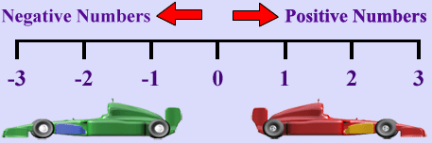

* **Vertical number line**

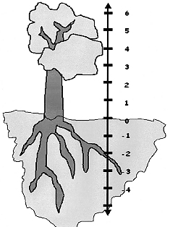

**Positive numbers**

**Negative numbers**

**4/4 Place value**

|  |  |  |  |
| --- | --- | --- | --- |
| thousands | hundreds | tens | units |
| **3** | **7** | **4** | **8** |

**3000**

**700**

**40**

**8**

**4/5 Roman Numerals to 100**

The numbers 1-100 are constructed from these:

I = 1  
V = 5  
X = 10  
L = 50  
C = 100

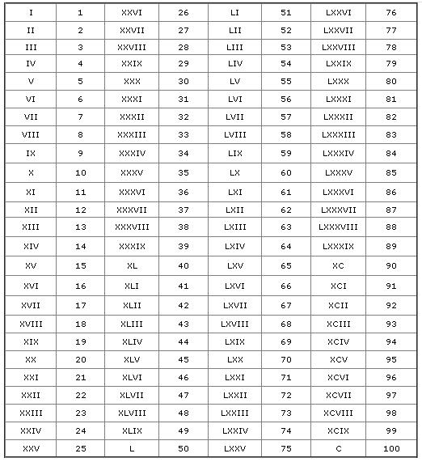

**4/6 Add & subtract**

* **Line up digits from right to left**

Example 1: Add 4735 and 386

4 7 3 5 4 7 3 5

+ 3 8 6 + 3 8 6

5 1 2 1 5 1 2 1

1 1 1 1 1 1

Example 2: Subtract 637 from 2476

21 14 76 16

- 6 3 7

1 8 3 9

**4/7 Estimate a calculation**

* Round off each number so that the calculation is easy to do

Example 1: 644 x 11

To make it easy use:

600x11=6600 or 600x10 =6000

Example 2: 503.926 + 709.328

To make it easy use:

500 + 700 = 1200

Example 3: Half of 51.4328963

To make it easy use:

Half of 50 = 25

Example 3: 806 - 209

To make it easy use:

800 – 200 = 600

**4/8 Addition & subtraction problems**

**(Based upon 4/6)**

**Words associated with addition:**

sum

total

altogether

add

Words associated with subtraction:

difference

Subtract

minus

How many more?

**4/9 Multiplication tables**

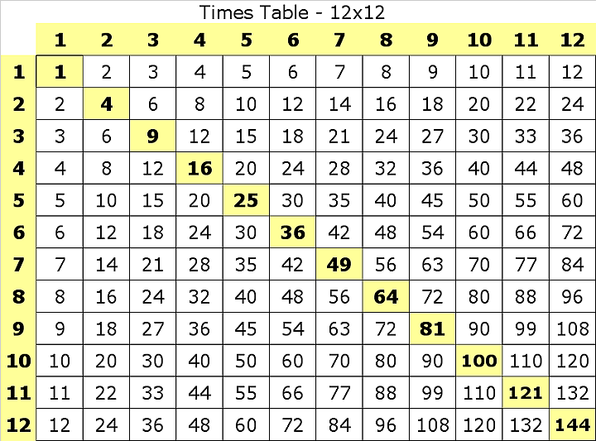

**Remember:**

7 x 8 = 56 8 x 7 = 56 56 ÷ 7 = 8 56 ÷ 8 = 7

**4/10 Factor pairs**

The number 12 can be made from these factor pairs

From these factor pairs we can see that the factors of 12 are: 1, 2, 3, 4, 6, 12

1 x 12

2 x 6

3 x 4

4 x 3

6 x 2

12 x 1

**4/11 Multiply by a single digit number**

Example: 342 x 7

3 4 2 300 x 7 = 2100

x 7  40 x 7 = 280

2 3 9 4 2 x 7 = 14

2 1 342 x 7 = 2394

**4/12 Connections between 2 sums**

* Look for connections between the 2 sums

Example: We know 342 x 7 = 2394 (See above)

x2

x2

So we also know 342 x 14 = 4788

Example: We know 342 x 7 = 2394 (See above)

x2

x2

So we also know 684 x 7 = 4788

Example: We know 342 x 7 = 2394 (See above)

+1

So we also know 342 x 8 = 2394 + (342 x 1)

= 2736

**4/13 Common equivalent fractions**

* The same fraction can be expressed in different ways

ALL THESE ARE 

 =  =  = 

ALL THESE ARE 

 =  =  = 

**4/14 Hundredths**

|  |  |  |  |  |
| --- | --- | --- | --- | --- |
| tens | units | . | 1/10 | **1/100** |
| 8 | 2 |  | 6 | **4** |

* This represents 4 hundredths = 
* To find a hundredth of an object or quantity you divide by 100

**4/14 Counting in hundredths (continued)**

O = 6.6**3**

P = 6.6**6**

Q = 6.7**2**

R = 6.7**7**

**4/15 Add & subtract fractions**

* To add and subtract fractions

**When the denominators are the same**

 +  =  = 1

Do not add

the denominators

 -  = 

Do not subtract

the denominators

**4/16 Decimal equivalents**

|  |  |  |
| --- | --- | --- |
| units |  | 1/10 |
| 0 |  | 6  0.6 ⬄ |

|  |  |  |  |
| --- | --- | --- | --- |
| units |  | 1/10 | 1/100 |
| 0 |  | 0 | 0.03 ⬄  3 |

|  |  |  |  |
| --- | --- | --- | --- |
| units |  | 1/10 | 1/100 |
| 0 |  | 6 | 0.63 ⬄  3 |

**4/16 Decimal equivalents**

Others to learn are:

 = 0.25  = 0.5  = 0.75

**4/17 Effect of dividing by 10 and 100**

* **To divide by 10, move each digit one place to the right**

e.g. 35 ÷ 10 = 3.5

|  |  |  |  |
| --- | --- | --- | --- |
| Tens | Units |  | 1/10 |
| 3 | 5 |  |
|  | 3 | 5 |

* **To divide by 100, move each digit 2 places to the right**

e.g. 35 ÷ 100 = 0.35

(we add a zero to show there are no whole numbers)

|  |  |  |  |  |
| --- | --- | --- | --- | --- |
| Tens | Units |  | 1/10 | 1/100 |
| 3 | 5 |  |  |
|  | 0 | 3 | 5 |

**4/18 Round decimals to nearest whole**

The Rules:

* If the digit behind the decimal point is **LESS THAN 5**, the number is rounded **DOWN** to the next whole number

Example: 6.**4** becomes rounded to 6

* If the digit behind the decimal point is **5 OR MORE**, the number is rounded **UP** to the next whole number

Example: 6.**5** becomes rounded to 7

6.**8** becomes rounded to 7

**4/19 Convert between units of measure**

* **Time**

x12

year

x4

months

÷12

X7

weeks

÷4

days

÷7

x60

hours

min

sec

x60

÷60

÷60

1

2

3

4

5

* **Length**

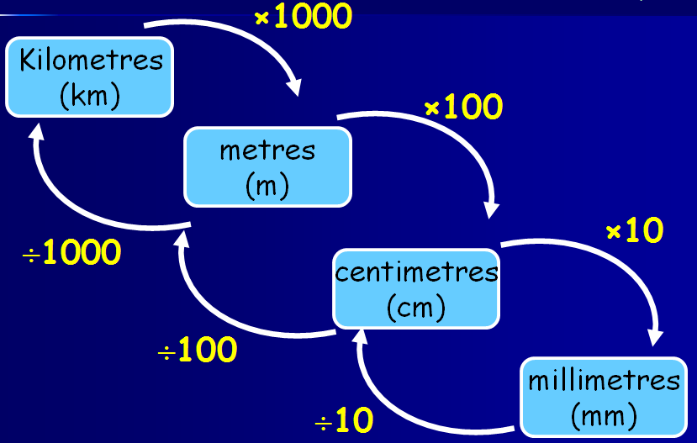

* **Mass or weight**

grams

(g)

kilograms

(kg)

**÷1000**

**x1000**

* **Capacity or volume**

millilitres

(ml)

litres

(l)

**x1000**

**÷1000**

**4/20 Perimeter & area by counting**

* **Perimeter** is round the **OUTSIDE**

Perimeter of this shape = 12cm



* **Area** is the number of squares **INSIDE**

Area of this shape = 5cm2



**4/21 Estimate measures**

* **Capacity**

a 5ml spoon

a 330ml can of drink

an average bucket holds 10 litres

**4/21 Estimate measures - continued**

* **Mass**

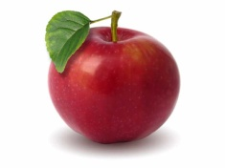this apple weighs 125g

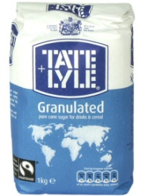this bag of sugar weighs 1kg

this man weighs 70kg

* **Length**

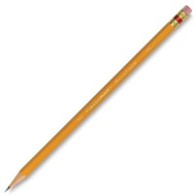this pencil is 17cm long

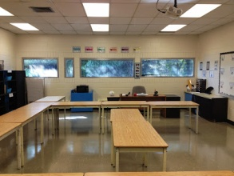 length of classroom is 10m

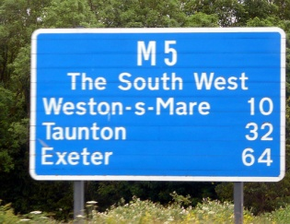distance to Exeter is 64miles

**4/22 12- and 24-hour clock**

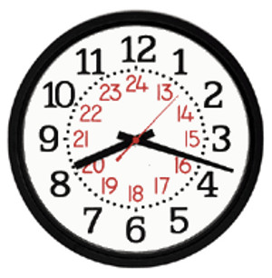

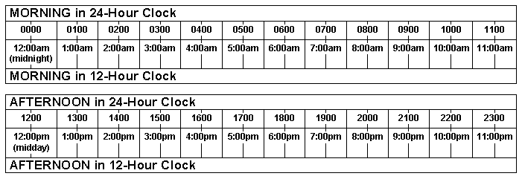

**4/23 – Properties of quadrilaterals &**

**triangles**

**TRIANGLES – angles add up to 1800**

***Isosceles triangle***

* 2 equal sides
* 2 equal angles
* 1 line of symmetry
* No rotational symmetry

***Equilateral triangle***

* 3 equal sides
* 3 equal angles - 600
* 3 lines of symmetry
* Rotational symmetry order 3

**QUADRILATERALS – all angles add up to 3600**

***Square***

* 4 equal sides
* 4 equal angles - 900
* 4 lines of symmetry
* Rotational symmetry order 4

***Rectangle***

* Opposite sides equal
* 4 equal angles - 900
* 2 lines of symmetry
* Rotational symmetry order 2

***Parallelogram***

* Opposite sides parallel
* Opposite angles equal
* NO lines of symmetry
* Rotational symmetry order 2

***Rhombus (like a diamond)***

* Opposite sides parallel
* Opposite angles equal
* 2 lines of symmetry
* Rotational symmetry order 2

**4/23 – Properties of quadrilaterals &**

**Triangles (continued)**

***Trapezium***

* ONE pair opposite sides parallel

***Kite***

* One pair of opposite angles equal
* 2 pairs of adjacent sides equal
* ONE line of symmetry
* No rotational symmetry

**4/24 Types of angles**

Acute Right Obtuse

(less than 900) (Exactly 900) (Between 900 & 1800)

Straight line

(1800 or two right angles)

**4/25 Identify lines of symmetry**

* **Horizontal line of symmetry**

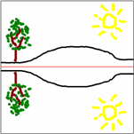

* **Vertical line of symmetry**

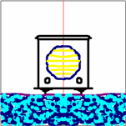

* **Oblique line of symmetry**



* **Horizontal, Vertical & Oblique lines of symmetry**

**4/26 Complete a symmetrical figure**

* **Tracing paper is brilliant for this**

|  |  |  |  |  |  |  |  |
| --- | --- | --- | --- | --- | --- | --- | --- |
|  | Example | | | | | |  |
|  |  |  |  |  |  |  |  |
|  |  |  |  |  |  |  |  |
|  |  |  |  |  |  |  |  |
|  |  |  |  |  |  |  |  |
|  |  |  |  |  |  |  |  |
|  |  |  |  |  |  |  |  |
|  |  |  |  |  |  |  |  |

|  |  |  |  |  |  |  |  |
| --- | --- | --- | --- | --- | --- | --- | --- |
|  |  |  |  |  |  |  |  |
|  |  |  |  |  |  |  |  |
|  |  |  |  |  |  |  |  |
|  |  |  |  |  |  |  |  |
|  |  |  |  |  |  |  |  |
|  |  |  |  |  |  |  |  |
|  |  |  |  |  |  |  |  |
|  |  |  |  |  |  |  |  |

|  |  |  |  |  |  |  |  |
| --- | --- | --- | --- | --- | --- | --- | --- |
|  |  |  |  |  |  |  |  |
|  |  |  |  |  |  |  |  |
|  |  |  |  |  |  |  |  |
|  |  |  |  |  |  |  |  |
|  |  |  |  |  |  |  |  |
|  |  |  |  |  |  |  |  |
|  |  |  |  |  |  |  |  |
|  |  |  |  |  |  |  |  |

**4/27 Describe position of points**

* The horizontal axis is the x-axis
* The vertical axis is called the y-axis
* The origin is where the axes meet
* A point is described by two numbers

The 1st number is off the x-axis

The 2nd number is off the y-axis

**y**

|  |  |  |  |  |  |
| --- | --- | --- | --- | --- | --- |
| **5**  **4**  **3**  **2**  **1** |  |  |  |  |  |
|  |  |  |  |  |  |
|  |  |  |  |  | **P** |
|  |  |  |  |  |  |
|  |  |  |  |  |  |
|  |  |  |  |  |  |

**0 1 2 3 4 5 6 x**

**Origin (0,0) P is (5, 3)**

**4/27 Describe movement of shapes**

**y**

|  |  |  |  |  |  |
| --- | --- | --- | --- | --- | --- |
| **5**  **4**  **3**  **2**  **1** |  |  |  |  |  |
| **A** |  |  |  |  |  |
|  |  |  |  |  |  |
|  |  |  |  |  |  |
|  |  |  | **B** |  |  |
|  |  |  |  |  |  |

**0 1 2 3 4 5 6 x**

Shape A has been moved 3 squares right and 2 down.

This movement is called TRANSLATION

**4/28 Complete a 2D shape**

Example: Draw on lines to complete parallelogram

**y**

|  |  |  |  |  |  |
| --- | --- | --- | --- | --- | --- |
| **5**  **4**  **3**  **2**  **1** |  |  |  |  |  |
|  |  |  |  |  |  |
|  |  |  |  |  |  |
|  |  |  |  |  |  |
|  |  |  |  |  |  |
|  |  |  |  |  |  |

**0 1 2 3 4 5 6 x**

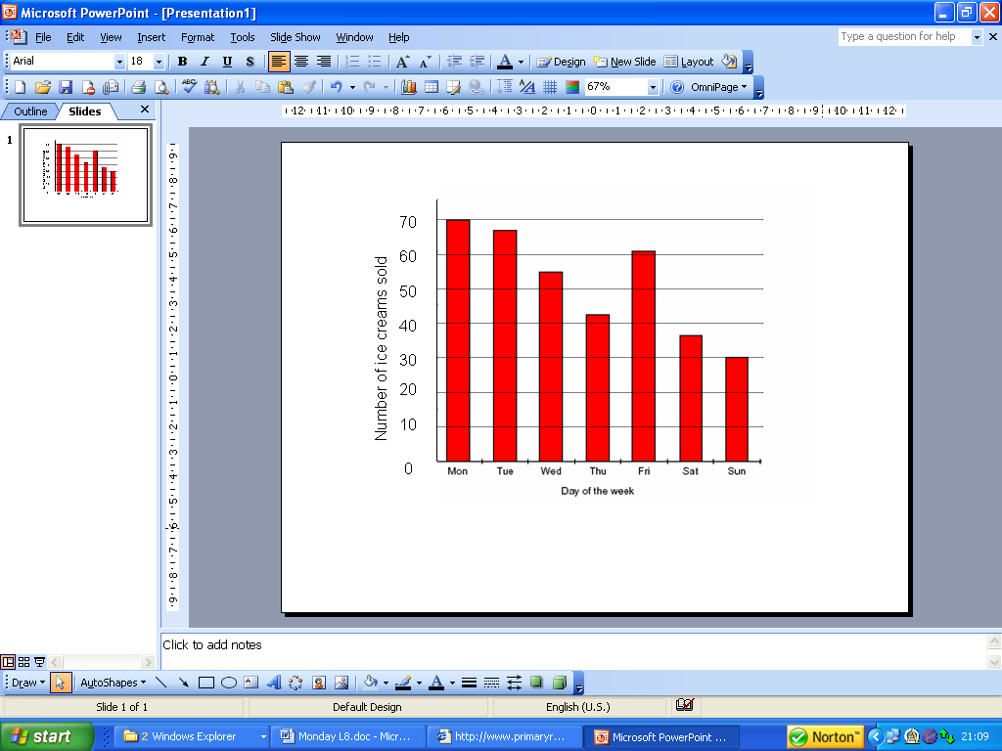

**4/29 Present discrete & continuous data**

**Discrete data** is counted

e.g. cars, students, animals

**Graph to show favourite colours in Class 4**

8

6

4

2

0

Red

Blue

Green

Colours

Frequency

Yellow

**4/29 Present discrete & continuous data**

**Continuous data** is measured

e.g. heights, times, temperature

**Graph to show a patient’s temperature over 24h**

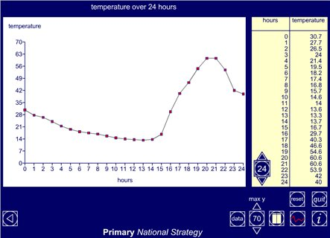

**4/30 Compare data in graphs**

‘Sum’ or ‘total’ means ‘add up’

‘Difference’ or ‘how many more’ means ‘subtract’

Bar chart to show Number of Ice Creams sold in a week

1. What is the total number of ice creams sold over the weekend?

Answer: 37 + 30 = 67

1. How many more were sold on Friday than Saturday?

Answer: 61 – 37 = 24

Pictogram to show the number of pizzas eaten by four friends in the past month:

Key showing that 1 pizza image equals 4 pizzas eaten

|  | |
| --- | --- |
| Alan | a whole pizzaHalf a pizza |
| Bob | a whole pizzaa whole pizzaone quarter of a pizza |
| Chris | a whole pizzaa whole pizzaa whole pizzaa whole pizzathree quarters of a pizza |
| Dave | a whole pizzaa whole pizzaa whole pizza |

1. What is the sum of the number of pizzas eaten in the month

Answer: 6 + 9 + 19 + 12 = 46

1. Find the difference in the number eaten by Chris and Bob

Answer: 19 – 9 = 10