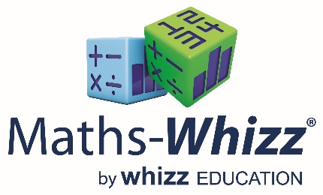

Dear Parent/Carer,
As part of Culcheth Primary School’s on-going improvement in the provision for maths, your child has access to Maths-Whizz Tutoring Plus, an online personalised tutoring service catering for each child’s unique ability. This is an online service and can be used at any time, at home as well as in school.
When used for the recommended amount of time, Maths-Whizz has been shown to help children improve and gain confidence in maths. You, as a parent, can contribute to your child getting the best results by scheduling time for your child to spend 20 to 30 minutes, two to three times a week, logging into Maths-Whizz. This can be accessed at www.whizz.com.
Lindsay, from Maths-Whizz, will be coming to our school on Wednesday 29th November at 2.45pm to provide a Parent Presentation of how Maths-Whizz can benefit your child and how you can help your child reach their potential. You will also have the opportunity for Q&A.
If you are able to attend, please return the slip below to the school by Monday 27th November 2017.
--------------------------------------------------------------------------------------------------------------------------------------
Maths-Whizz Presentation
I, _________________________________________________, will be attending the Maths-Whizz Presentation on Wednesday 29th November at 2.45pm.

Child: _________________________________ Class: _____________________

