How to use Maths-Whizz on an iPad/Tablet

Dear parent/carer,

Your child has access to their own virtual online maths tutor which provides maths lessons catered to your child’s unique ability. After an online assessment to establish your child’s Maths Age, these lessons are delivered to support your child to progress in maths and help build confidence.
Maths-Whizz is a fun way to learn with lots of animations and rewards. Your child can improve their maths skills with all the help they need, no adult guidance needed.
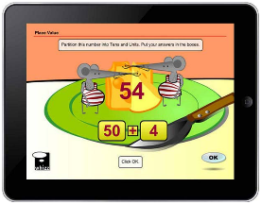
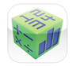
Maths-Whizz on tablets
Your child will receive the best experience when using a laptop/PC, however, you can download the Maths-Whizz app from your app store.

If you have any questions, please contact: customer.success@whizz.com or call 0203 328 6564 Mon-Fri, 8:30am-5pm (excluding Bank Holidays).
www.whizz.com

How to use Maths-Whizz on an iPad/Tablet

Dear parent/carer,

Your child has access to their own virtual online maths tutor which provides maths lessons catered to your child’s unique ability. After an online assessment to establish your child’s Maths Age, these lessons are delivered to support your child to progress in maths and help build confidence.
Maths-Whizz is a fun way to learn with lots of animations and rewards. Your child can improve their maths skills with all the help they need, no adult guidance needed.
Maths-Whizz on tablets
Your child will receive the best experience when using a laptop/PC, however, you can download the Maths-Whizz app from your app store.

If you have any questions, please contact: customer.success@whizz.com or call 0203 328 6564 Mon-Fri, 8:30am-5pm (excluding Bank Holidays).
www.whizz.com

