WARRINGTON BOROUGH COUNCIL

Culcheth Community Primary School

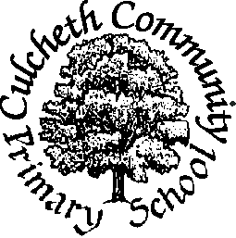

Warrington Road, Culcheth, Warrington WA3 5HH.
Where Learning is Fun!

Tel: 01925 764312/Fax: 01925 764690
Email culcheth_primary@warrington.gov.uk
www.culchethprimary.co.uk

Headteacher
Mrs A Dodd BSc (Hons) NPQH
4th May 2017

Dear parent/carer

Please see below Culcheth Community Primary School’s offer for Early Help for families:

Early Help Offer at Culcheth Community Primary School
Early Help refers to the offer of any information, advice or support to children, young people and their families as soon as possible in their lives, or when issues emerge, to help prevent problems from escalating.
Listed below are some of the services the school can offer you:-
- On Tuesday afternoons from 2.30pm we will be holding an informal ‘drop in’ for parents to come and chat to Mrs Lynskey about any support that they might require. We can help with signposting and referrals to external agencies such as: the Family Outreach Team, parenting courses, our School Health Advisor, St Joseph’s Family Centre, Child Development Centre, CAMHS and local children’s centres.
- Mrs Dodd the head teacher, is also available to talk to parents/carers most mornings on the playground when you drop your children at school to discuss any concerns you may have regarding behaviour, learning or any other support you require.
- We offer support to complete forms and other paperwork such as high school admissions.
- Completion of Common Assessment Framework (CAF) and Early Help Assessments which involves listening to you to find out what help you need and talking about what is working well in your life. Based on what you say and what help you would like, a plan is put together so that professionals can work together to make sure you get the right sort of help.
- At Culcheth Community Primary School, our Safeguarding Team meet every two weeks to identify any children and families who would benefit from early help. It allows them to access services in the school and beyond to support identified vulnerable pupils.
- A worry box is available to all pupils in the main hall so that they can write their worries down and know that they will be dealt with in a sympathetic and safe way.
If you have any queries, please do not hesitate to contact the school for more information
Kindest regards
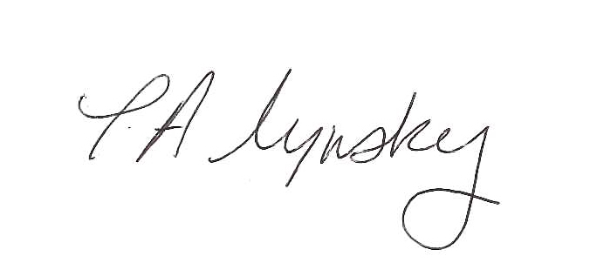
Tracy Lynskey
School Family Support Worker

