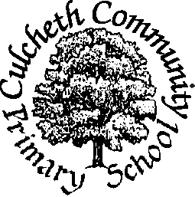
Where Learning is Fun!

Culcheth Community Primary school

Allegations of Abuse Against Staff Policy

Culcheth Community Primary School recognises that an allegation may be made against a member of staff.

If such an allegation is made, the member of staff receiving the allegation will immediately inform the Head teacher. The Head teacher should then inform the Chair of Governors.

The Head teacher on all such occasions will discuss the content of the allegation with the LA’s Senior Adviser for Safeguarding Children in Education within 1 working day.

If the allegation made to a member of staff concerns the Head teacher, the designated teacher will immediately inform the Chair of Governors who will consult with the LA’s Senior Adviser for Safeguarding Children in Education.

The school will follow the LA procedures for managing allegations against staff, a copy of which will be readily available in the school.

Reference should be made to Appendix 5 from “Working together to Safeguard Children” 2006.

All members of staff and other regular volunteers within the school will be asked to read this policy.

This policy will be reviewed on an annual basis, in conjunction with other Child Protection policies.

Other relevant documentation:
Handling Allegations of Abuse made against Adults who work with Children and Young people. Practice Guidance. May 2009 DCSF.

