WE INVITE YOU TO OUR FREE PARENT WORKSHOPS
AT
CULCHETH COMMUNITY PRIMARY
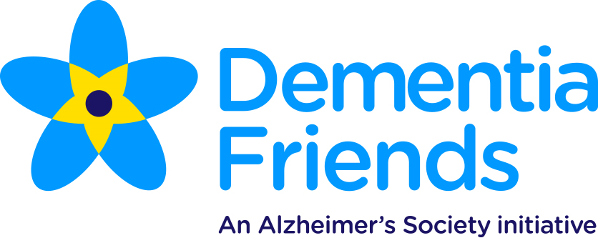
16TH OCTOBER 9AM-10AM

Friends Information Sessions are run by Dementia Friends Champions to help you understand what it's like to live with dementia and the actions you can take.

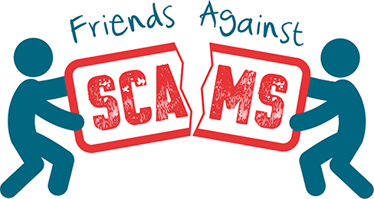
9TH NOVEMBER 9AM-10AM

Friends Against Scams is designed to inspire action, highlight the scale of the problem, change the perceptions of why people fall for scams and make scams a community, regional and national topic. By attending a Friends Against Scams awareness session or completing the online learning, anyone can learn about the different types of scams and how to spot and support a victim.

For more information please contact Nikki on 07583029724 or email
nattwood@warrington.gov.uk

