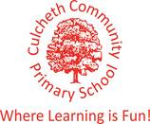

Our Sporting Diary 2017 – 2018

September

Charity Skydive

On the 1st September, our Headteacher, Mrs Dodd, undertook the challenge of completing a skydive for charity. The small plane took off with Mrs Dodd inside, and after it reached 3 miles high, the small shutter opened and Mrs Dodd jumped out of the plane. She was so incredibly brave! Travelling at 125 mph for the first 30 seconds of the fall must have been very scary. Mrs Dodd raised a huge amount of money for The Children’s Cancer Ward Piam Brown. Well done Mrs Dodd!

CPD Real Gymnastics

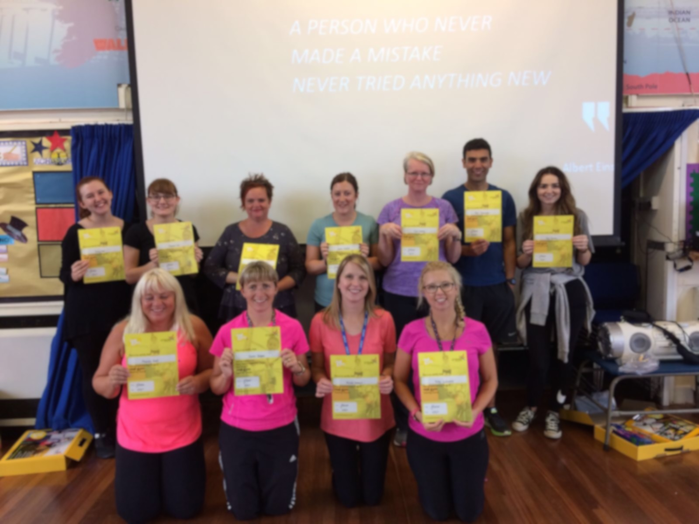
All of the teaching staff attended and successfully completed training delivered by Jan Parker on REAL Gymnastics. The training was held as an inset day at our school. It was a fantastic course and has provided all teaching staff with the skills, knowledge and resources needed to deliver effective, challenging and differentiated gymnastics lessons. From the course, we learnt how to teach the skills and build the difficulty and challenge up in order to challenge more able children. We also looked at how we can teach gymnastics not only indoors, but also outdoors. Both outdoor areas, KS1 and KS2 have access to fantastic equipment which children can use during gymnastics lessons, to explore making shapes as well as exploring balance and jumps, but children can also use this equipment and their knowledge from gymnastics lessons during break time to practise their skills. This aids in making gymnastics fun and accessible not only in lessons but at break times as well. All staff really enjoyed the training and feel more prepared and ready to give REAL gymnastics a try in their PE lessons. One member of staff commented “The course has been really beneficial. It has not only developed my knowledge of how gymnastics skills are developed throughout the school, but by also looking at safety, especially on apparatus, it has developed my confidence in bringing out the climbing frames ect out more in lessons.”

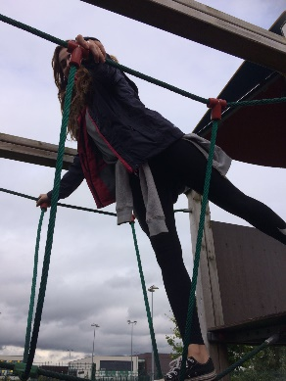
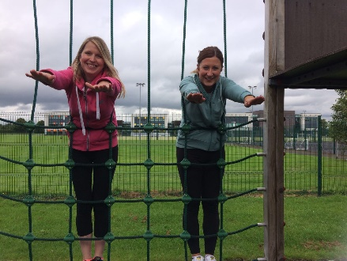

100 mile challenge

After last year’s success, each child in KS2 has been set the challenge to complete 100 miles over the academic year again. The children thoroughly enjoyed this last year and we have chosen to set the children this challenge again. Everyday, the children will take part in completing a mile and they do this on the track around our school field. All children are extremely enthusiastic to complete this challenge and to monitor their steps over the year.

Total Gymnastics Assembly

On Friday 7th July, Total Gymnastics visited the school and delivered an assembly. The assembly was focused around how gymnastics can develop a range of fundamental movements. They also focused on the importance of trying new things, encouraging the children to partake in new sports (you never know how good you might be unless you have tried). The children thoroughly enjoyed the assembly and were even offered a free taster session.

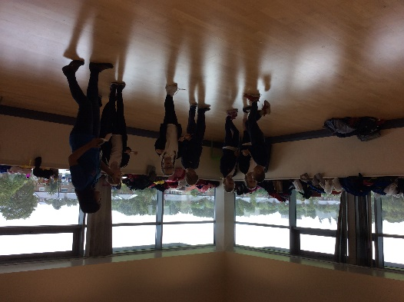
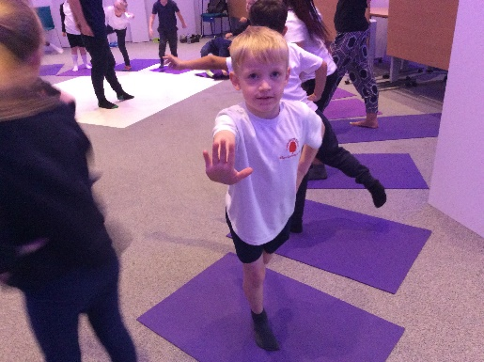
KS1 Road to the Gold Coast Event

We took 30 children from KS1 to the festival ‘Road to the Gold Coast’. The children took part in a range of activities including: Yoga, Dance, Drama and multi-skills. They also had the opportunity to take part in workshops which taught them about keeping a balanced diet and its importance. The children had a fantastic time.

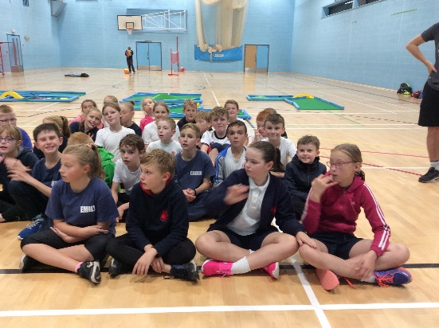
KS2 Triathlon Event

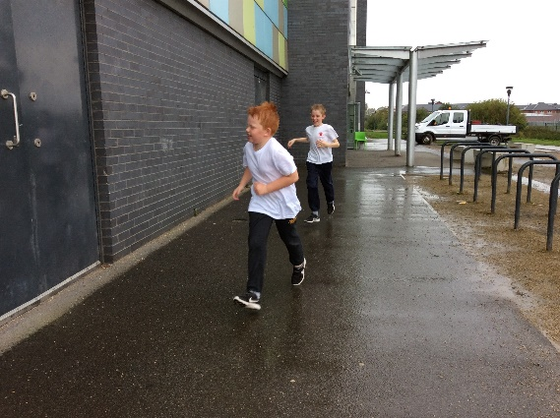
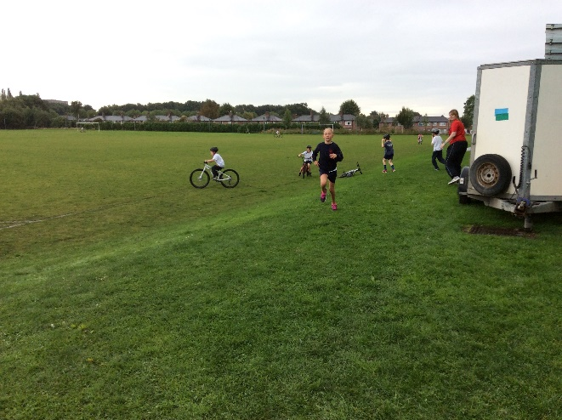
On Friday 22nd September, 27 children from years 4, 5 and 6 attended a triathlon event at Orford Jubilee Hub. The children were required to swim for 25m, complete a short bike ride as well as a run all in the confines of Orford Jubilee Hub. All of the children had a brilliant time exploring the new sports involved in the triathlon.

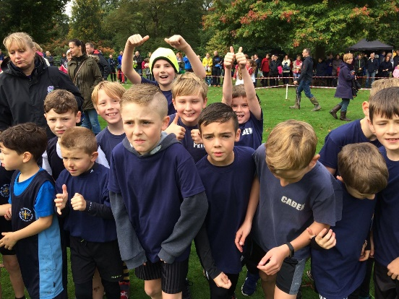
Walton Gardens Cross Country

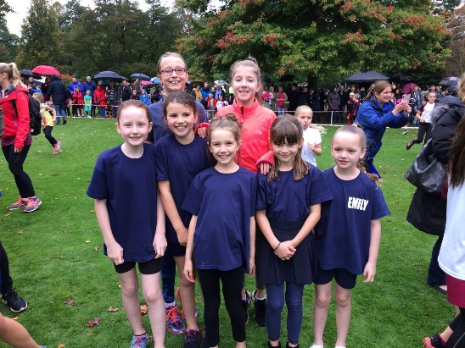
On Saturday 30th September, the running team took part in the first of three cross country races. The children did exceptionally well in the rain and wind. Everyone is looking forward to the next two races to see if we can improve on our first performance of this academic year.

October

Tennis Workshop

KS1 children had the opportunity to take part in a tennis work shop on Monday 2nd October. All children really enjoyed the taster session. They learned lots of new skills as well as being given the opportunity to apply their learned skills from our REAL PE scheme to a game situation.

Ability Day

6 children attended the ability day at Orford Jubilee Hub on Wednesday 11th October. The aim of the day was to provide students, who would not normally get the opportunity to represent their school, the chance to partake in multi-sport activities. The children had the chance to take part in football, archery, boccia and table cricket. Each child left with a medal for partaking in the day.

Year 3/4 Basketball Development Day

Seven children from years 3 and 4 took part in a basketball development session on Tuesday 17th October at Sir Thomas Botler Ball Hall. This event was run by Warrington Sports Partnership and involved the children playing a total of 4 matches. The event was aimed at developing children’s basketball skills in game situations and for all of the children who took part, it was their first ever time playing a basketball match. Overall, the children won two matches and lost one match. They all played brilliantly and thoroughly enjoyed the event.

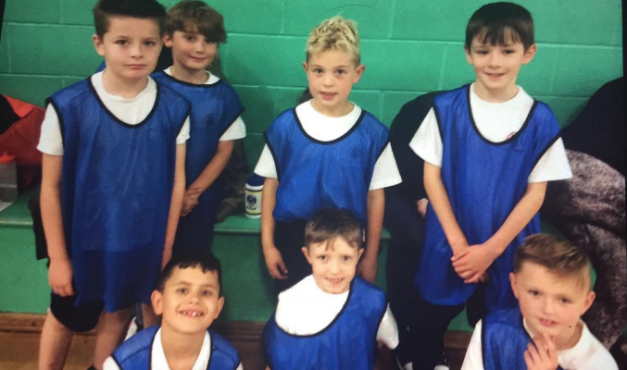

Year 5/6 Football Match

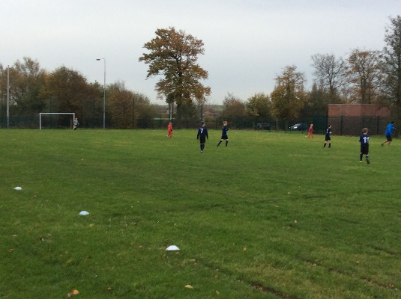
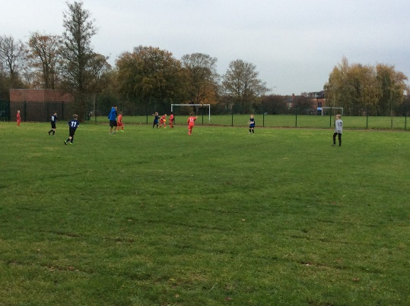
On Tuesday 31st October our Year 5/6 Football team took on Birchwood Primary School in a friendly match, at home, on our school field. Mr Chesworth refereed the match and all of the boys tried their best. Fun was had by all and the boys are looking forward to the next match.

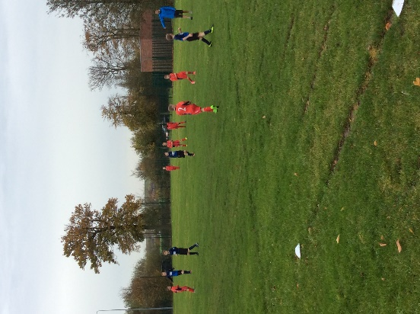

Year 3/4 and Year 5/6 Football Match

On Tuesday 7th November both of our football teams played a friendly match against Chapelford Village Primary School. All of the boys who played tried really hard and despite the cold, really enjoyed the game. It was fantastic to see the teamwork and great sportsmanship on display from all involved. Mr Chesworth refereed the Year 5/6 match and Chapelford refereed the Year 3/4 match. They are looking forward to the rematch in December.
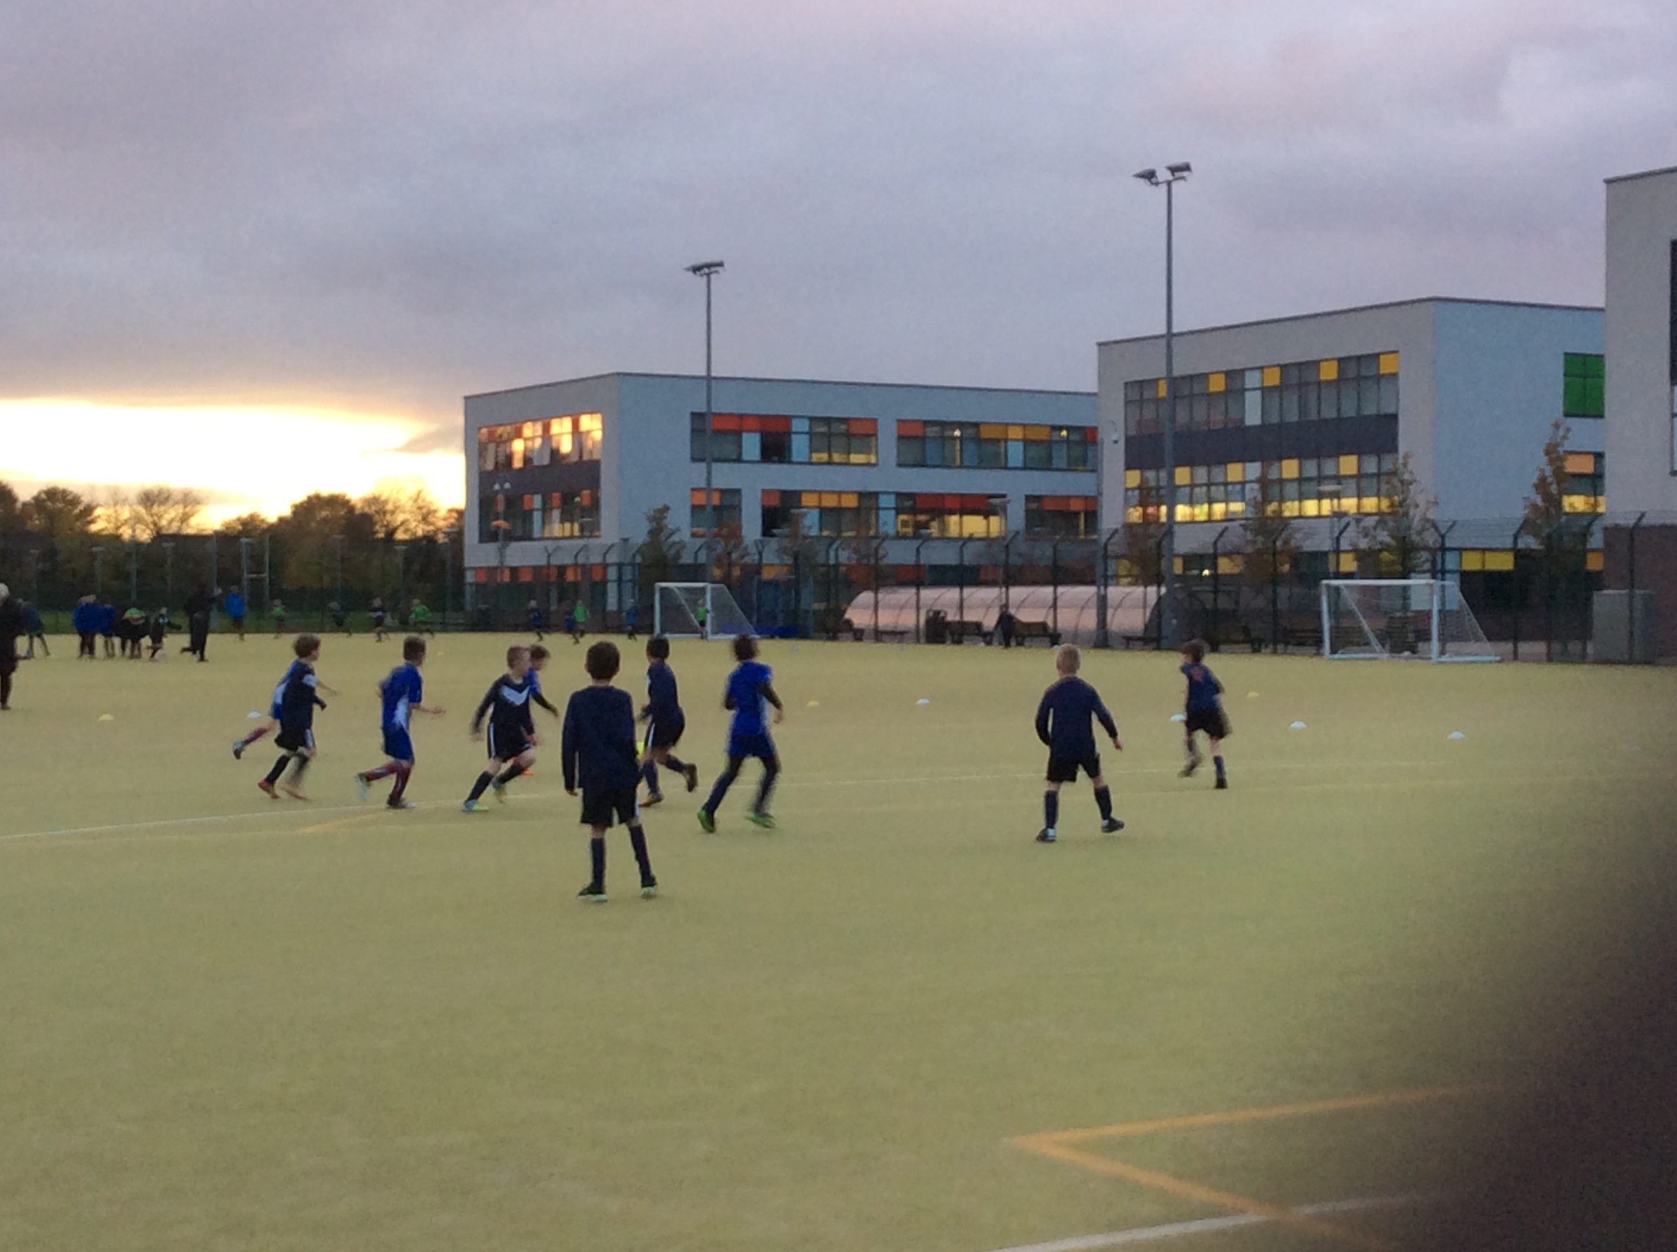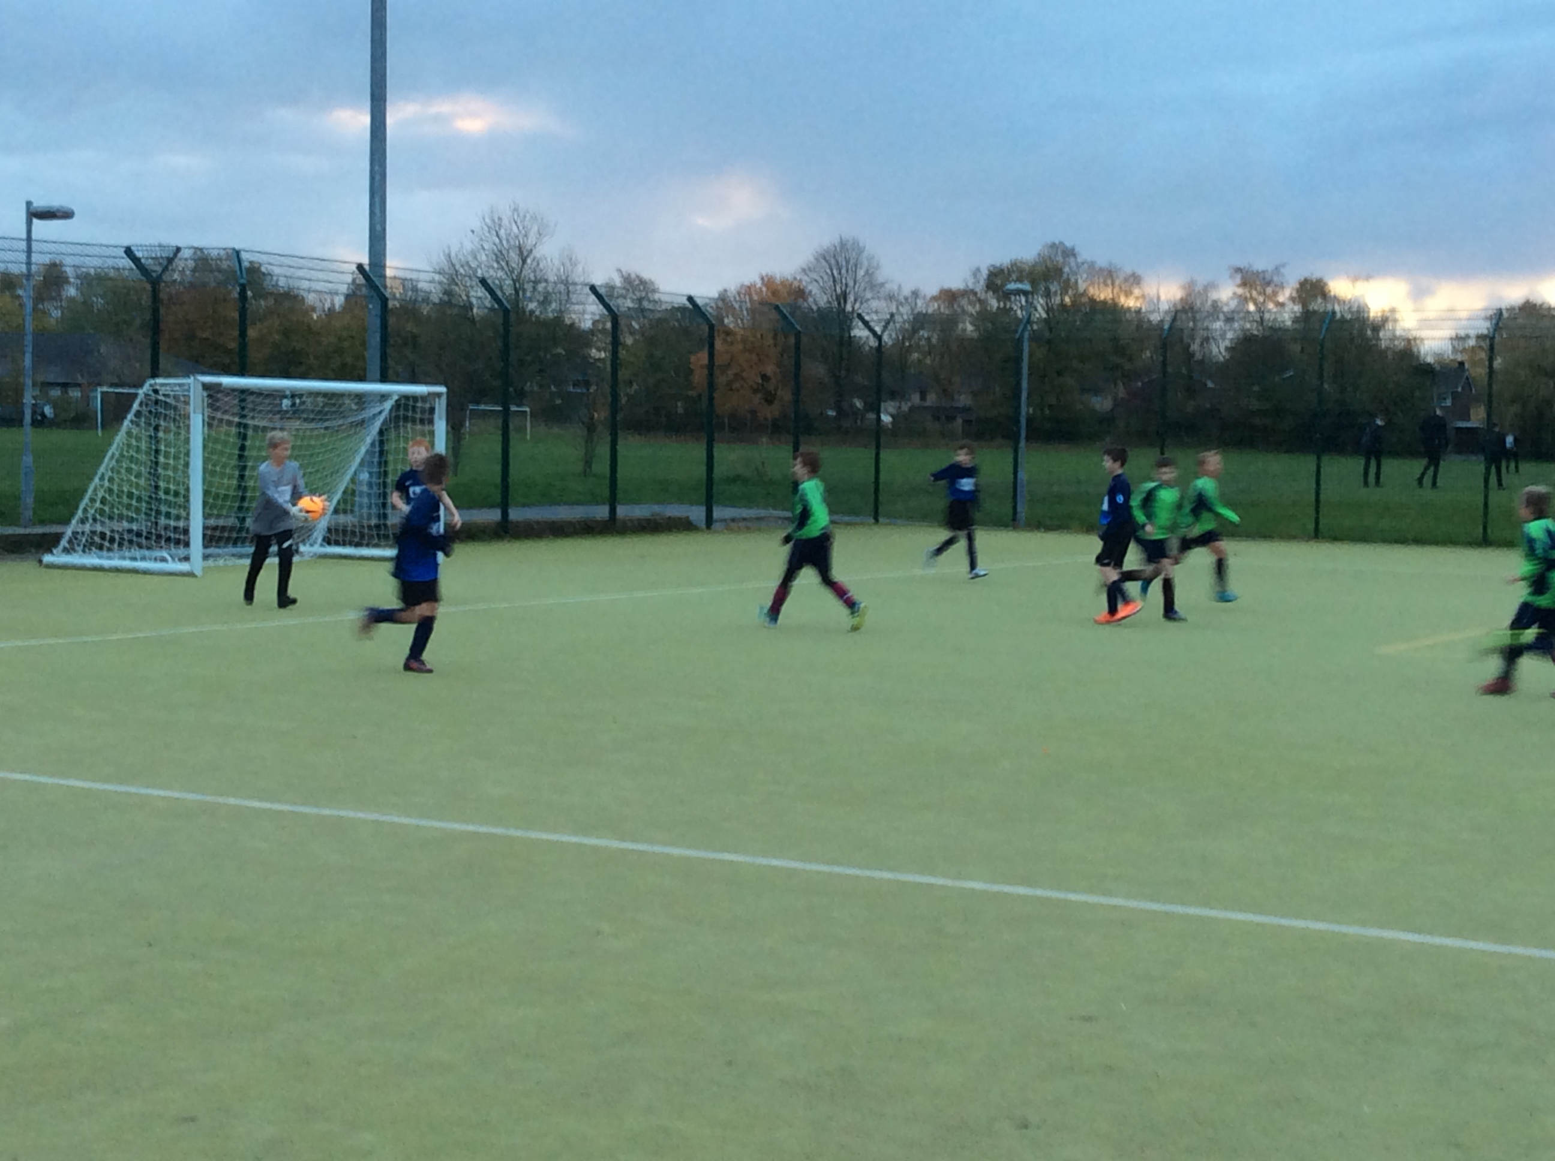

Year 4 and 5 Swimming Lessons

This year we have changed our swimming lessons from Irlam to the SWIM Centre in Warrington. This is a new, purpose built swimming centre in Warrington. The children in Y4 and Y5 are enjoying putting on their swimming caps and learning new skills.

PE Cluster Meeting

On the 11th October, Miss Lea attended the PE Cluster Meeting held at Callands Community Primary School. Around 15 schools were in attendance and we discussed how we can improve sport across Warrington. This meeting will be a regular half termly meeting, where PE Subject Leads can share ideas and discuss ways to improve sport in schools across Warrington.

Primary Sports Leadership Camp

During October half term, 5 children from Y6 were selected to take part in a sports leadership camp over three days at Priestley College. The children had the opportunity to experience a range of sports as well as learn how to lead sports activities back in school. The following sports were covered during this camp:

- Tag Rugby
- Sportshall Athletics
- Hockey
- Personal Challenge
- Dodgeball
- Gynmastics

The children are looking forward to the next camp in April.

Sara | Harry | Culcheth | F | 6 | Y | Y | Y
Kristians | Krastins | Culcheth | M | 6 | Y | Y | Y
Billy | Lawerence | Culcheth | M | 6 | Y | Y | Y
Dominic | Smith | Culcheth | M | 6 | Y | Y | Y
Ella | Wall | Culcheth | F | 6 | Y | Abs | Abs

November

Warrington Wolves Assembly

We have a great partnership with The Warrington Wolves Foundation and they made their first visit of the year to deliver an assembly to all of KS1 and KS2 on the 14th November. Will from Warrington Wolves talked to the children about the importance of perseverance and how having a positive attitude can not only help you in sport but is something that we should be doing all of the time. We are looking forward to their next visit.

KS2 Netball Match

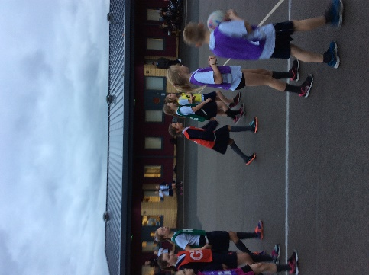
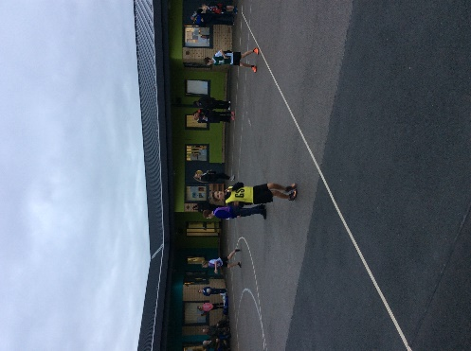
Our netball team made the journey to Chapelford Village Primary School for our first Netball friendly of the year on Tuesday 14th November. The children really tried their best and produced an outstanding performance winning 9-4. What a fantastic achievement, all of the children really enjoyed themselves despite the cold weather. We are looking forward to our next match.

Year 3/4 Football Match

On Tuesday 14th November our Year 3/4 Football Team took on Birchwood C of E in a friendly match. They all played extremely hard and brought home the victory for Culcheth, winning 6-2. The match was held at home on our school field. Congratulations team!

Year 5/6 Football Match

On Friday 17th November, the Year 5/6 Football Team welcomed back Birchwood C of E for another game, held on our school field. It was a very close game. With 1 minute to go the game was tied 3-3, and in the last 10 seconds Birchwood scored to take the match 4-3. The boys played extremely well and are looking forward to their next match.

Walton Gardens Cross Country Race 2

On Saturday 18th November, Mrs Rodgers, Miss Lea and 20 of our runners from Running Club attended the second of three cross country runs held at Walton Gardens. The runners and staff were praying that the weather would be better than it was for the first race. The children performed exceptionally. We had the most children running for our school out of the whole competition (the best turnout of all Warrington Schools). This particular race had 166 girls running and 170 boys running, this was the highest turnout ever for the race. Ella Wall came a very impressive 4th and Dominic Smith came an impressive 14th, improving on his 26th place finish in the previous race. Our girls’ team even made it into the Warrington Guardian Newspaper. Well done to all!

Global Learning Session and Staff CPD

On Monday 20th November, Years 2 and 3 had the opportunity to take part in Global Learning Sessions. The children in Year 2 looked at Earth Education, exploring the schools surroundings and looking at using their five senses to explore this. The children loved being outdoors, the particularly enjoyed making cocktails using materials from around school. The children in Year 3 were lucky enough to take part in some philosophy for children outdoors. They particularly enjoyed exploring the environment and recording their observations, by using chalk to write them down on the school playground. All children thoroughly enjoyed their time outdoors.

After school it was the turn of the staff, Mrs Dodd, Mrs Rodgers, Miss Lea, Miss Knowles and Miss Ball all attended the CPD Session focusing on Global Learning and Philosophy for children (P4C). The CPD session gave all the staff lots of ideas that can be trialled in class as well as a range of ideas for the upcoming Green Day. Mrs Rodgers particularly enjoyed playing with the mud in the school playground in an attempt to protect an egg. Further CPD will be provided on how we can use the outdoor environment and philosophy for children in conjunction with each other. This will be available to all staff in school.

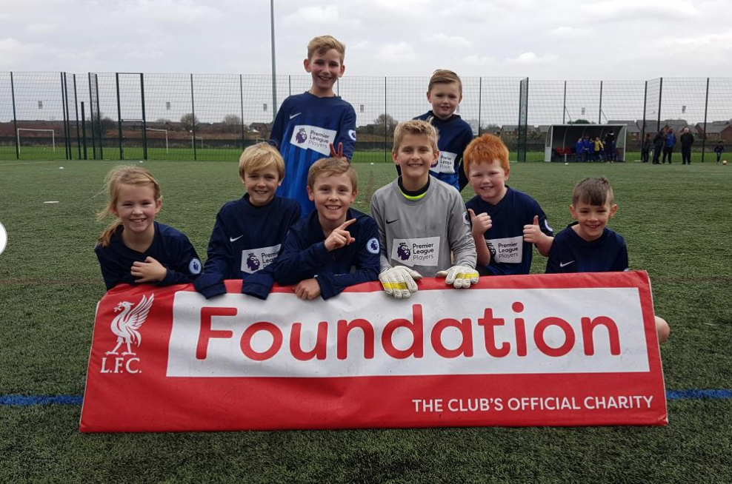
Liverpool Premier League Schools Football Tournament

On Thursday 23rd November, Mr Chesworth was very excited about taking a group of children to Liverpool Football Club in order to participate in a Premier League Schools Football Tournament. The matches were 6-a-side and played on the training pitches (astroturf). The children really enjoyed their day and loved the experience.

December

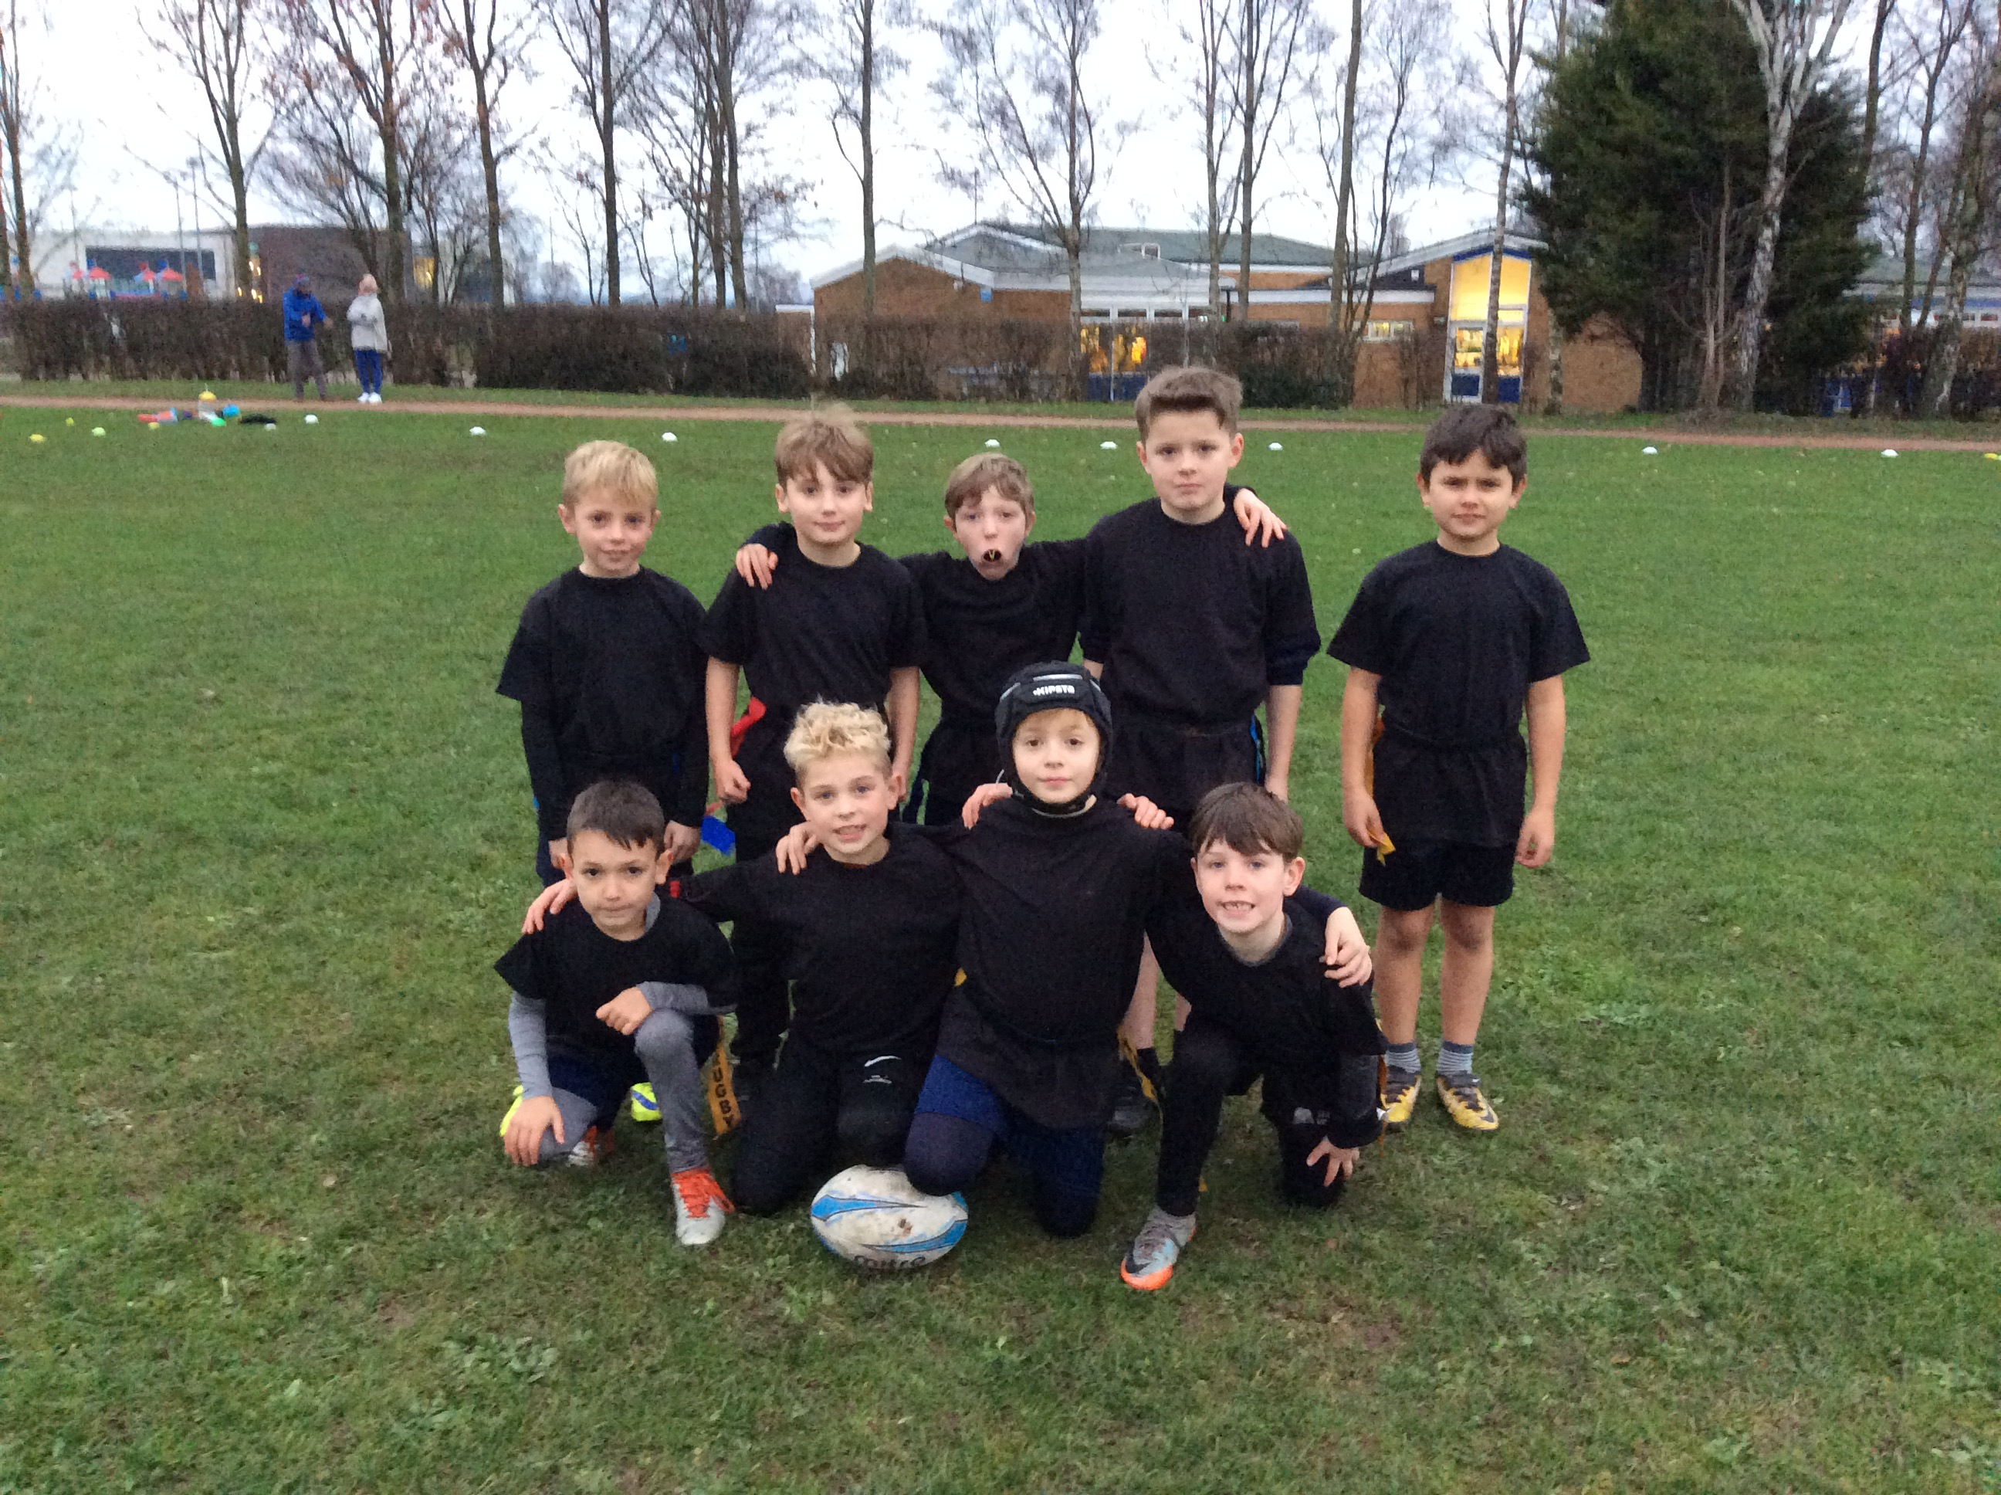
Year 3/4 Rugby Match

On Tuesday 5th December, our Year 3/4 Rugby Team played a nail-biting tag rugby friendly match against Chapelford Village Primary School. The boys played incredibly well and went home extremely muddy. We are looking forward to our rematch.

Walton Gardens Cross Country Race 3

On Saturday 9th December our running team ran in the final Walton Gardens Race of the year. Both the boys and girls team performed incredibly with special mentions going to Ella Wall for coming in 15th and Dominic Smith who came in 13th place. Again, Culcheth Primary School were the most represented school at the event and despite the blizzard conditions the children represented the school extremely well. We are looking forward to next year’s Walton Gardens Event, but are looking forward to the remaining running event this academic year.
