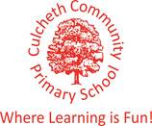

Our Sporting Diary 2017 – 2018

September

Charity Skydive

On the 1st September, our Headteacher, Mrs Dodd, undertook the challenge of completing a skydive for charity. The small plane took off with Mrs Dodd inside, and after it reached 3 miles high, the small shutter opened and Mrs Dodd jumped out of the plane. She was so incredibly brave! Travelling at 125 mph for the first 30 seconds of the fall must have been very scary. Mrs Dodd raised a huge amount of money for The Children’s Cancer Ward Piam Brown. Well done Mrs Dodd!

CPD Real Gymnastics

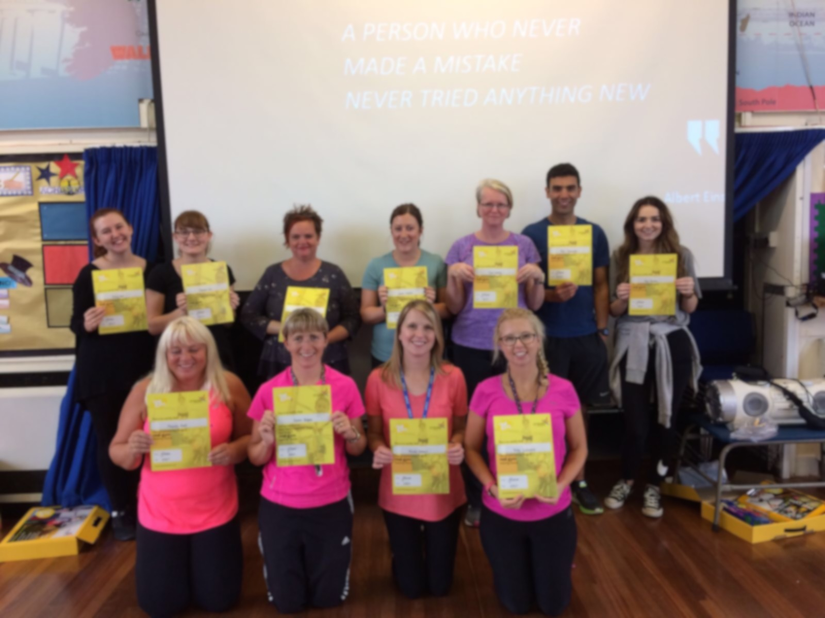
All of the teaching staff attended and successfully completed training delivered by Jan Parker on REAL Gymnastics. The training was held as an inset day at our school. It was a fantastic course and has provided all teaching staff with the skills, knowledge and resources needed to deliver effective, challenging and differentiated gymnastics lessons. From the course, we learnt how to teach the skills and build the difficulty and challenge up in order to challenge more able children. We also looked at how we can teach gymnastics not only indoors, but also outdoors. Both outdoor areas, KS1 and KS2 have access to fantastic equipment which children can use during gymnastics lessons, to explore making shapes as well as exploring balance and jumps, but children can also use this equipment and their knowledge from gymnastics lessons during break time to practise their skills. This aids in making gymnastics fun and accessible not only in lessons but at break times as well. All staff really enjoyed the training and feel more prepared and ready to give REAL gymnastics a try in their PE lessons. One member of staff commented “The course has been really beneficial. It has not only developed my knowledge of how gymnastics skills are developed throughout the school, but by also looking at safety, especially on apparatus, it has developed my confidence in bringing out the climbing frames ect out more in lessons.”

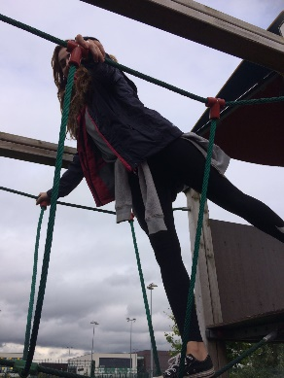
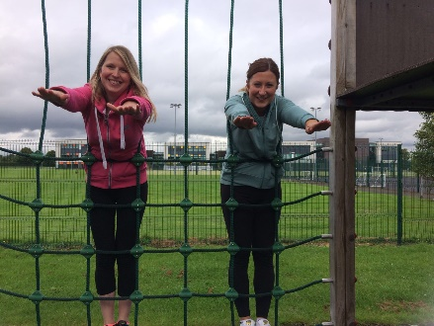

Total Gymnastics Assembly

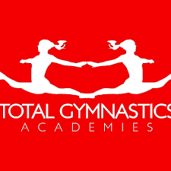
On Friday 7th July, Total Gymnastics visited the school and delivered an assembly. The assembly was focused around how gymnastics can develop a range of fundamental movements. They also focused on the importance of trying new things, encouraging the children to partake in new sports (you never know how good you might be unless you have tried). The children thoroughly enjoyed the assembly and were even offered a free taster session.

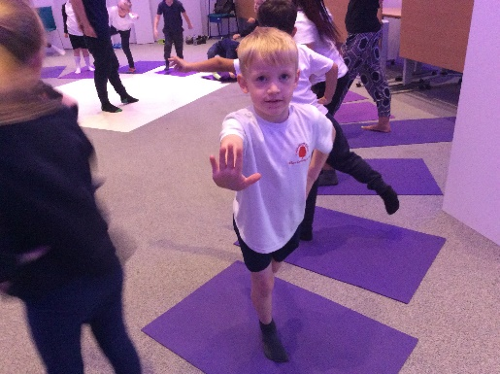

KS1 Road to the Gold Coast Event

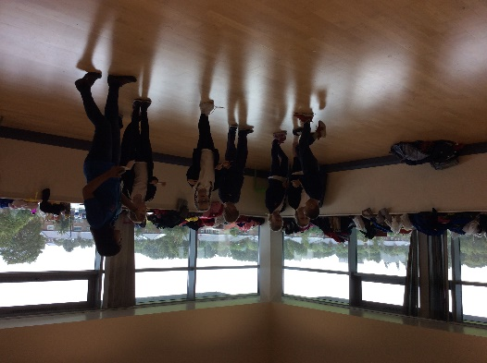
We took 30 children from KS1 to the festival ‘Road to the Gold Coast’. The children took part in a range of activities including: Yoga, Dance, Drama and multi-skills. They also had the opportunity to take part in workshops which taught them about keeping a balanced diet and its importance. The children had a fantastic time.

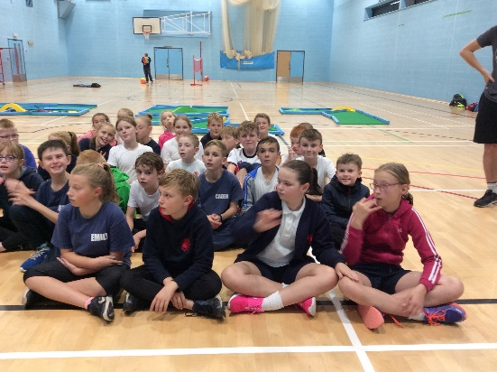
KS2 Triathlon Event

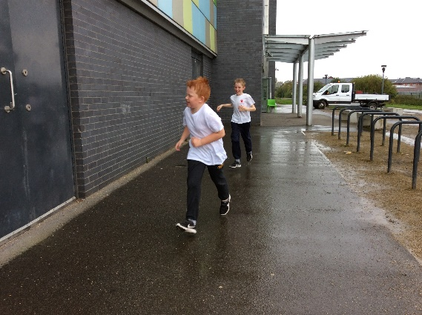
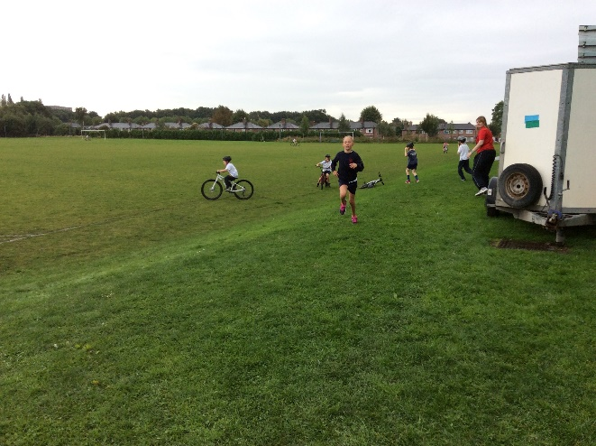
On Friday 22nd September, 27 children from years 4, 5 and 6 attended a triathlon event at Orford Jubilee Hub. The children were required to swim for 25m, complete a short bike ride as well as a run all in the confines of Orford Jubilee Hub. All of the children had a brilliant time exploring the new sports involved in the triathlon.

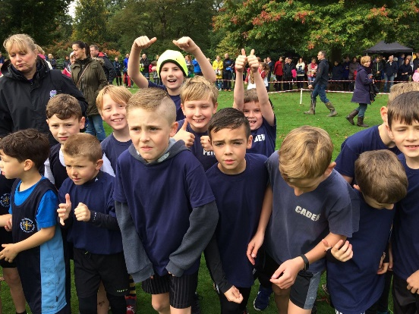
Walton Gardens Cross Country

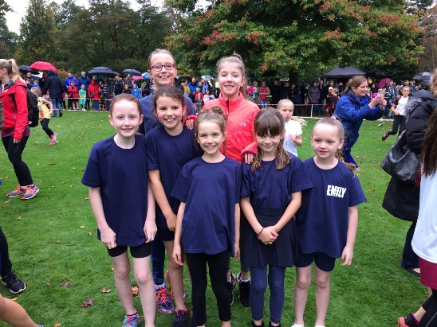
On Saturday 30th September, the running team took part in the first of three cross country races. The children did exceptionally well in the rain and wind. Everyone is looking forward to the next two races to see if we can improve on our first performance of this academic year.

October

Tennis Workshop

KS1 children had the opportunity to take part in a tennis work shop on Monday 2nd October. All children really enjoyed the taster session. They learned lots of new skills as well as being given the opportunity to apply their learned skills from our REAL PE scheme to a game situation.

Ability Day

6 children attended the ability day at Orford Jubilee Hub on Wednesday 11th October. The aim of the day was to provide students, who would not normally get the opportunity to represent their school, the chance to partake in multi-sport activities. The children had the chance to take part in football, archery, boccia and table cricket. Each child left with a medal for partaking in the day.

Year 3/4 Basketball Development Day

Seven children from years 3 and 4 took part in a basketball development session on Tuesday 17th October at Sir Thomas Botler Ball Hall. This event was run by Warrington Sports Partnership and involved the children playing a total of 4 matches. The event was aimed at developing children’s basketball skills in game situations and for all of the children who took part, it was their first ever time playing a basketball match. Overall, the children won two matches and lost one match. They all played brilliantly and thoroughly enjoyed the event.

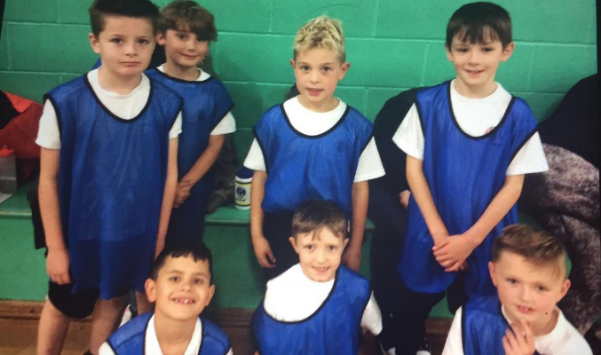

Year 5/6 Football Match

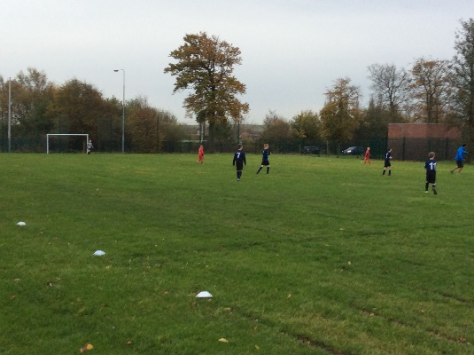
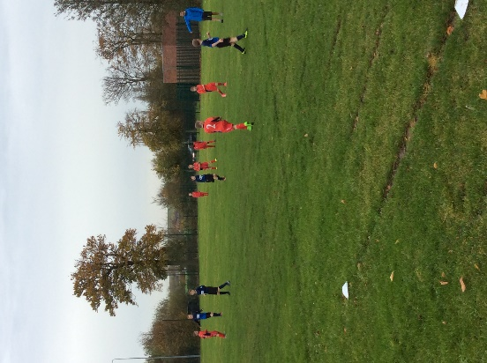
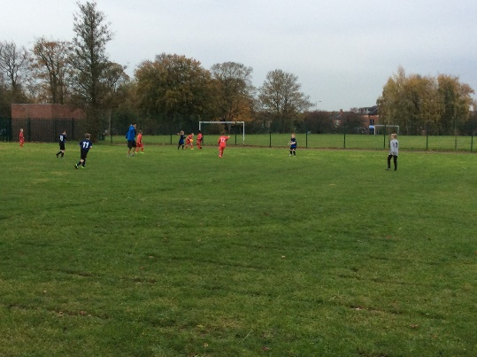
On Tuesday 31st October our Year 5/6 Football team took on Birchwood Primary School in a friendly match, at home, on our school field. Mr Chesworth refereed the match and all of the boys tried their best. Fun was had by all and the boys are looking forward to their next friendly match.

