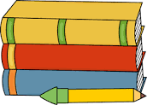
Year 2
Spring Term Overview

English | Narrative  - Elephant by Petr Horeck  - The disgusting Sandwich by Gareth Edwards  Poetry  - Animal Poetry  Instructions  - How to make a sandwich
Maths | Multiplication and Division  Measurement (mass, capacity and length)  Statistics
Science | Living Things and their Habitats
Geography | Where in the world?  Looking at the continents and oceans
ICT | We are detectives
Art | Wolf Khan – Trees
RE | Christianity – Jesus  What do people think is important to do weekly, daily, monthly? Why are these important?
PE | REAL PE Scheme Unit 3  Dance
SMSC | Emotions and The Environment

