SimSimi – The new app that is linked to online bullying
Have you heard about SimSimi? It is a popular app that has recently been linked to significant levels of online bullying between children and young people. This explains what it is and how it can be misused. Critically, it also highlights the safety tools available in the app alongside some practical safeguarding advice.
What is it? - At the most basic level, SimSimi is a chat app. When a user types a message a chatbot (short for chat robot - a computer programme that simulates human conversation) replies.
How does it work? - This technology is not unique to SimSimi. It is in used in other areas and lots of companies use chatbots for their FAQs and online help.
SimSimi has a ‘Words Management’ feature which allows users to teach the chatbot certain words and terms which in turn, it can use to reply to particular questions. Users can therefore "teach" SimSimi inappropriate, sexually explicit and offensive language. This can result in young people who use it receiving abusive replies when they type their own name into the app. Whilst in a number of cases the response may be targeted at a specific young person, in reality, the same response can appear for anyone with the same or similar name. Children who ask SimSimi questions about themselves might therefore feel hurt and many people mischievously teach SimSimi to respond inappropriately to innocent questions.
What safety tools does it have?
The app has a limited number of tools to help make the environment safer for users.
Bad Words: there is an option to turn off bad words so they don't appear in the app. This is a good idea but as with most things it is not 100% accurate.
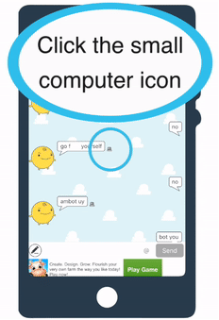 Reporting: Responses can be marked as being ‘not interesting', ‘sexually explicit', ‘vulgar or violent' or ‘other’. It is not clear as to what happens once content is reported. There is currently very little information available on the website about its terms of use or how it deals with flagged content.
The app does state: ‘Harass, abuse, defame or otherwise infringe on any other party, you may be subject to civil or criminal penalties.’ It is not clear how this is moderated.

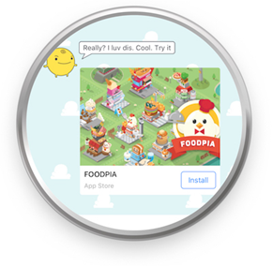Advertising (it's all about the Money!)
In common with most apps, SimSimi draws its intial revenue from Click-through advertising. Adverts pop-up with irritating regularity & unsurprisingly users have the in-app purchase option to remove ads. Users also have the the ability by purchasing points to link comments to content.
What else?
Remember! Children who don't use the App don't know what is being said about them, so those who bully tend to draw their attention to it, either directly or via a friend. Remember to ask a child who is upset by content on it how they found out about the app.
If you have legitimate and lawful access to a child or young persons phone you can access the Word Management feature in their SimSimi app menu. This will disclose 'Words taught by me' where you will be able to see the actual words, phrases and links which the user has 'taught' SimSimi.
Device Settings
You can prevent a child or young person from access the app on their device if you preset age restrictions and limit in-app purchases.
SimSimi App Store Age Rating: 17+
SimSimi Google Play Store: PEGI 16
Dated April 2017

