WARRINGTON BOROUGH COUNCIL

Culcheth Community Primary School

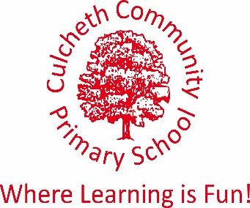
Warrington Road, Culcheth, Warrington WA3 5HH.

Tel: 01925 764312/Fax: 01925 764690
Email culcheth_primary@warrington.gov.uk
www.culchethprimary.co.uk

Headteacher
Mrs A Dodd BSc (Hons) NPQH

29.08.18

Dear Parents/Carers

I am writing to you to let you know that the dates for the Kingswood residential have been changed.
The trip will now take place from 24th – 28th June 2019 and be at the smaller centre near Wolverhampton.

Kingswood were unable to accommodate our trip in October due to a clash with an adult booking that they had made. They would not allow primary school children to be on site at the same time as an adult party.

The trip in June will be honoured at the same price, although, had we booked at this time initially, the cost of the trip would have been £350 (including transport). The activities offered will be the same as at Dearne Valley and as we are at a smaller centre, there will be less of a rush for meals etc. We hope that the change of dates will actually be positive, as it is after SATS tests and, hopefully, the weather should be mild. It will also give you a longer time to pay for the trip – adjustments will be made on ParentPay as we return to school.

Thank you for your continued support.

If you have any queries, please do not hesitate to contact me.

Kind regards

Mrs Dodd

