Cosmic

Frank Cottrell-Boyce
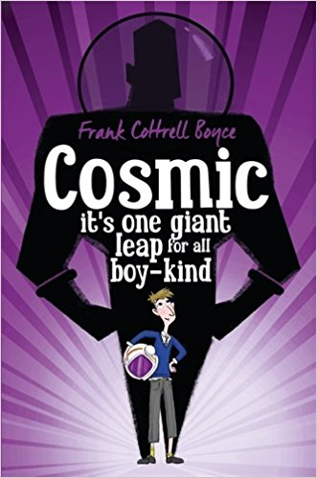

Liam is too big for his boots. And his football strip. And his school blazer. But being super-sized height-wise has its advantages: he's the only eleven-year-old to ever ride the G-force-defying Cosmic rollercoaster - or to be offered the chance to drive a Porsche. Long-legged Liam makes a giant leap for boy-kind by competing with a group of adults for the chance to go into space. Is Liam the best boy for the job? Sometimes being big isn't all about being a grown-up.

The Huntress: Sea

Sarah Driver

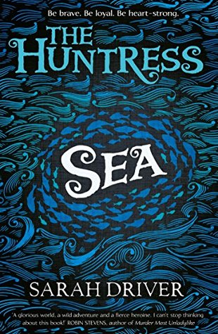

In the sky, the fire spirits dance and ripple. Grandma says they showed our Tribe that I’d be a captain, before I was even born.
Ever since Ma died, Mouse has looked after her little brother, Sparrow, dreaming of her destiny as captain of the Huntress. But now Da’s missing, Sparrow is in danger, and a deathly cold is creeping across Trianukka . . .

Letters From The Lighthouse

Emma Carroll

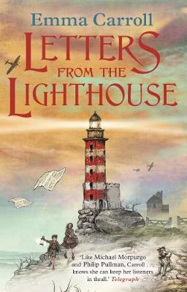

February, 1941. After months of bombing raids in London, twelve-year-old Olive Bradshaw and her little brother Cliff are evacuated to the Devon coast. The only person with two spare beds is Mr Ephraim, the local lighthouse keeper. But he's not used to company and he certainly doesn't want any evacuees.
Desperate to be helpful, Olive becomes his post-girl, carrying secret messages (as she likes to think of the letters) to the villagers. But Olive has a secret of her own. Her older sister Sukie went missing in an air raid, and she's desperate to discover what happened to her. And then she finds a strange coded note which seems to link Sukie to Devon, and to something dark and impossibly dangerous.

The Jamie Drake Equation

Christopher Edge
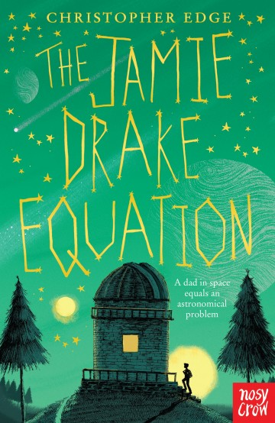

How amazing would it be to have a dad who's an astronaut? Rocket launches, zero gravity, and flying through space like a superhero! Jamie Drake's dad is orbiting the Earth in the International Space Station and Jamie ought to think it's cool but he just really misses him...Hanging out at his local observatory, Jamie picks up a strange signal on his phone. It looks like alien life is getting closer to home. But space is a dangerous place and when his dad's mission goes wrong, can Jamie prove that he's a hero too?

A Place Called Perfect

Helena Duggan

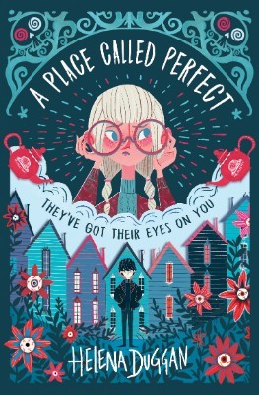

Violet never wanted to move to Perfect. Who wants to live in a town where everyone has to wear glasses to stop them going blind? And who wants to be perfectly behaved all the time? Violet quickly discovers there's something weird going on, and when she meets Boy she realizes that the mysterious Watchers are guarding a perfectly creepy secret!

Artemis Fowl

Eoin Colfer

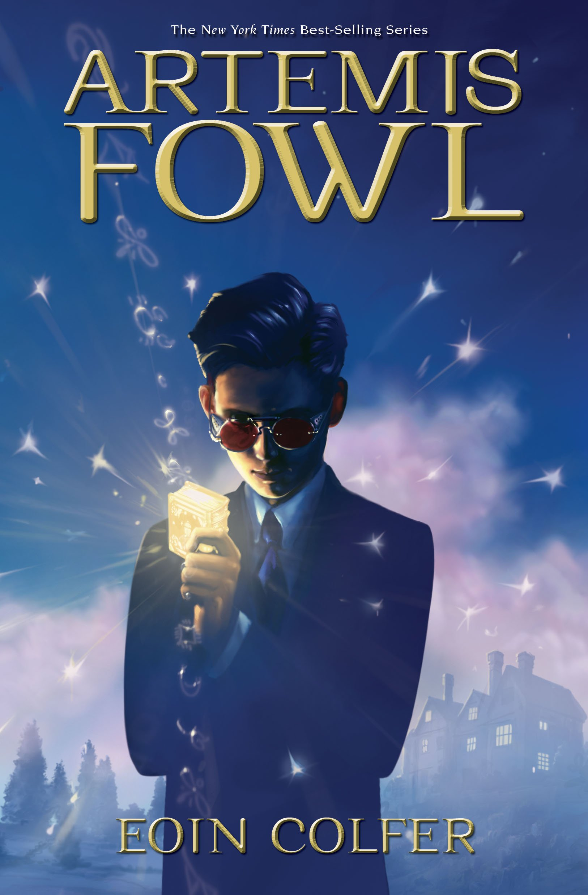

Twelve-year-old villain, Artemis Fowl, is the most ingenious criminal mastermind in history. His bold and daring plan is to hold a leprechaun to ransom. But he's taking on more than he bargained for when he kidnaps Captain Holly Short of the LEPrecon (Lower Elements Police Reconnaissance Unit). For a start, leprechaun technology is more advanced than our own. Add to that the fact that Holly is a true heroine and that her senior officer Commander Root will stop at nothing to get her back and you've got the mother of all sieges brewing!

The Legend Of Podkin One-Ear

Kieran Larwood
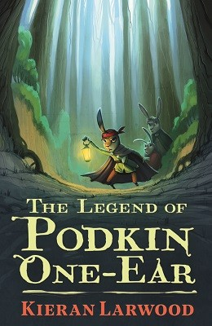

Podkin is the son of a warrior chieftain. He knows that one day it will be up to him to lead his warren and guard it in times of danger. But for now, he's quite happy to laze around annoying his older sister Paz, and playing with his baby brother Pook. Then Podkin's home is brutally attacked, and the young rabbits are forced to flee. The terrifying Gorm are on the rampage, and no one and nowhere is safe. With danger all around them, Podkin must protect his family, uncover his destiny, and attempt to defeat the most horrifying enemy rabbitkind has ever known.

Beetle Boy

Mg Leonard

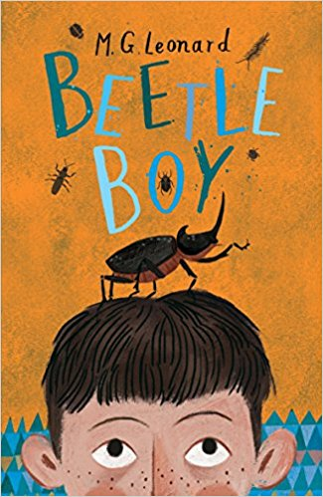

Darkus is miserable. His dad has disappeared, and now he is living next door to the most disgusting neighbours ever. A giant beetle called Baxter comes to his rescue. But can the two solve the mystery of his dad's disappearance, especially when links emerge to cruel Lucretia Cutter and her penchant for beetle jewellery? A coffee-mug mountain, home to a million insects, could provide the answer - if Darkus and Baxter are brave enough to find it .

