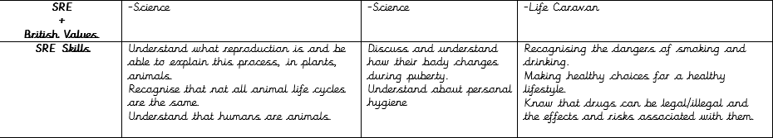

These are the themes which are covered in the Year 5 curriculum for SRE. Depending on the needs of the children and questions raised other topics can be covered. All SRE is covered in Year 5 through the science curriculum or visits to the Life Caravan or specific needs of the current year group.

