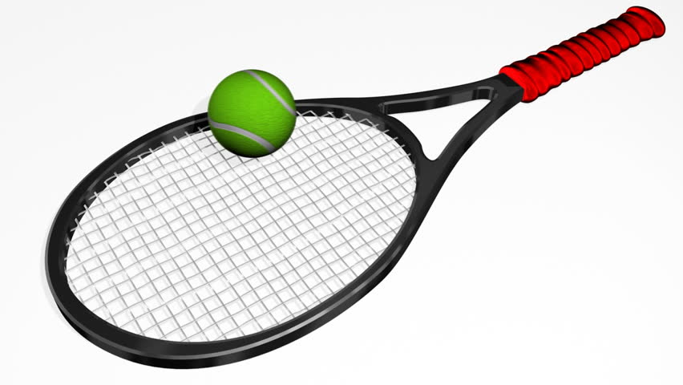

CULCHETH TENNIS CLUB

Tennis is a great way to keep active over the summer and is deemed to be a safe activity to play during the current situation.

Culcheth tennis club can offer group and individual coaching sessions and can cater for all levels.

Junior membership is just £10 for the year!

For more information on group coaching or individual lessons including holiday activities, please contact Head Coach Gary Brookes on
07879626230 or by email at gazbrookes007@googlemail.com

https://clubspark.lta.org.uk/culchethtennisclub/Membership/Join

