WARRINGTON BOROUGH COUNCIL

Culcheth Community Primary School

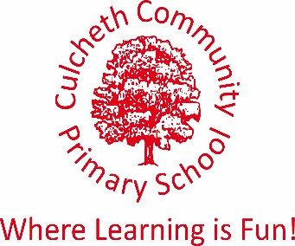
Warrington Road, Culcheth, Warrington WA3 5HH.

Tel: 01925 764312/Fax: 01925 764690
Email culcheth_primary@warrington.gov.uk
www.culchethprimary.co.uk

Headteacher
Mrs A Dodd BSc (Hons) NPQH

27th February 2019

Dear Parent/Carer

New After-School Club “Forest School”

We are offering a new after-school club called ‘Forest School’ which will start on Thursday 14th March for a duration of 6 weeks. The club will offer outside activities including den building, gardening, plants and tools.

The club will start at 3.15pm and finish at 4.30pm and is aimed at Year 2-6. The cost of the club is £5 for a 6 week course ending on Thursday 2nd May (taking into account Easter holidays).

If you would like to book your child on to this club, please complete the tear off below and return to the school office with £5. We can only offer a maximum number of 15 children therefore this will be allocated on a first come, first served basis.

Yours sincerely

Amanda Dodd
Headteacher

-----------------------------------------------------------------------------------------------------------------------

FOREST SCHOOL
AFTER-SCHOOL CLUB

Child’s Name: ______________________________

I would like to book my child on the above after-school club. I enclose £5.

Signed: ______________________________ Date: ___________________

