Autumn 1- A home for a family  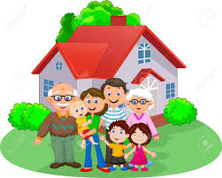 | During this half term we will be looking at different types of families and understanding that every family is different. We will look at and talk about our feelings and learn how to deal with them.  In our Science lessons we will be looking at body parts and naming them.  In our RE lessons we will be learning about the festival of Diwali and how it is celebrated around the world. We will also look at the Harvest festival and attend our local church in order to celebrate the festival.
Autumn 2- If you go down to the woods  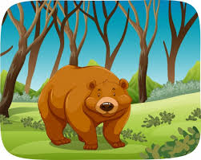 | During this half term we will be looking at bears. We will be reading different stories such as We’re going on a bear hunt and Goldilocks and the three bears.  In our History lessons we will be learning about the history of Bonfire night and how Guy Fawkes was involved.  In our Science lessons we will be looking at the different seasons and weather and how they change throughout the year.  In our Art and Design lessons we will be looking at the artist Jackson Pollock and creating our own work using his style and techniques.  In our RE lessons we will be looking at the ‘Christmas Story’ and talking about Jesus.
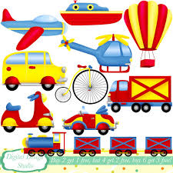  Spring 1- Are we there yet? | During this half term we will be looking at transport and journeys.  In our History lesson we will look at transport in the past and now and compare them.  In our Geography lessons we will look at maps and our journeys to school.  In our RE lessons we will look at Chinese New Year and how it is celebrated around the world.
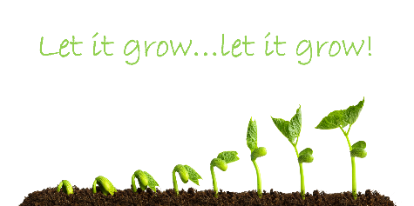  Spring 2- Let it grow, let it grow | During this half term we will be looking at how things grow.  In our Science lessons we will be looking at different mini beasts, the life cycle of a chick, parts of a flower and how seeds grow. We will be looking after some baby chicks and watching them hatch from an egg.  In our RE lessons we will be looking at Easter and how it is celebrated around the world. We will be talking about why we have Easter and how different people celebrate it.

