WARRINGTON BOROUGH COUNCIL

Culcheth Community Primary School

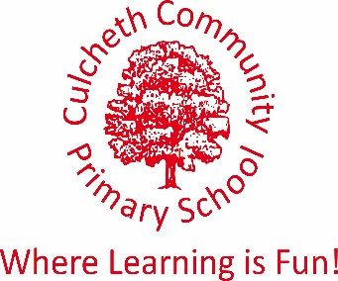
Warrington Road, Culcheth, Warrington WA3 5HH.

Tel: 01925 764312/Fax: 01925 764690
Email culcheth_primary@warrington.gov.uk
www.culchethprimary.co.uk

Headteacher
Mrs A Dodd BSc (Hons) NPQH

28th June 2018

Reception Graduation

Dear Parent / Carer,

On Wednesday 18th July at 2.50pm in the School Hall, the children will be presented with their Graduation Certificates.

The children will be wearing special caps and gowns and we would like to invite family members to come and celebrate with us.

Please note the gowns are provided by school, but need to be returned by the end of the day.

There will be an opportunity for lots of photographs following the assembly and refreshments will be provided for our children and their special guests.

It is a lovely occasion and we hope that you will be able to join us.

Please complete the slip below and return to school.

Many thanks

Miss Wardle
Reception Class Teacher

Reception Graduation

I/We are able to attend my child’s Graduation and require _______ seats.

I/We are unable to attend

Child’s name: _________________________________________

Signed: _____________________________________________ (Parent/Carer)

